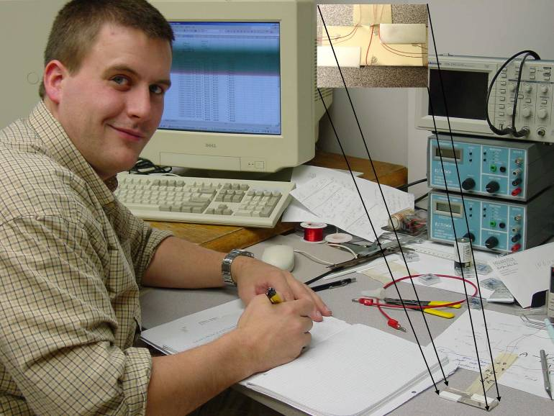

Hall Effects in Thin Films

Paul M Harrison

Advisor: Dr. Tariq Gilani

A sculptured thin film (STF) has a columnar microstructure that is very much like a forest of trees. Some columns may possess bent, chevron or spiral characteristics in addition to an overall angle measured from the normal to the substrate. The Hall Effect can be used to gain an understanding of the charge carriers in a material. Valuable insights were gained through the apparent failure of several tests run looking for a Hall Effect in the chrome STFs. Making workable, non-damaging electrical contacts on the STFs is not a trivial feat. Wires cannot be silver pasted or hot soldered to the film; these methods allow conductive material to flow among the columns, changing the electrical characteristics of the STFs. Making cold soldered connections using indium as the solder makes usable contacts on evaporated thins films that are not sculptured; this method should work with STFs. While working with evaporated silver films manufactured at Millersville I noticed the Hall coefficient is dependant upon thickness of the film. Comparisons of 60nm and 33nm thick films with the bulk Hall coefficient values show an inverse relationship with the thickness of the film and the Hall coefficient. Preliminary observations with STFs also indicate the columns do not act like capacitors.

