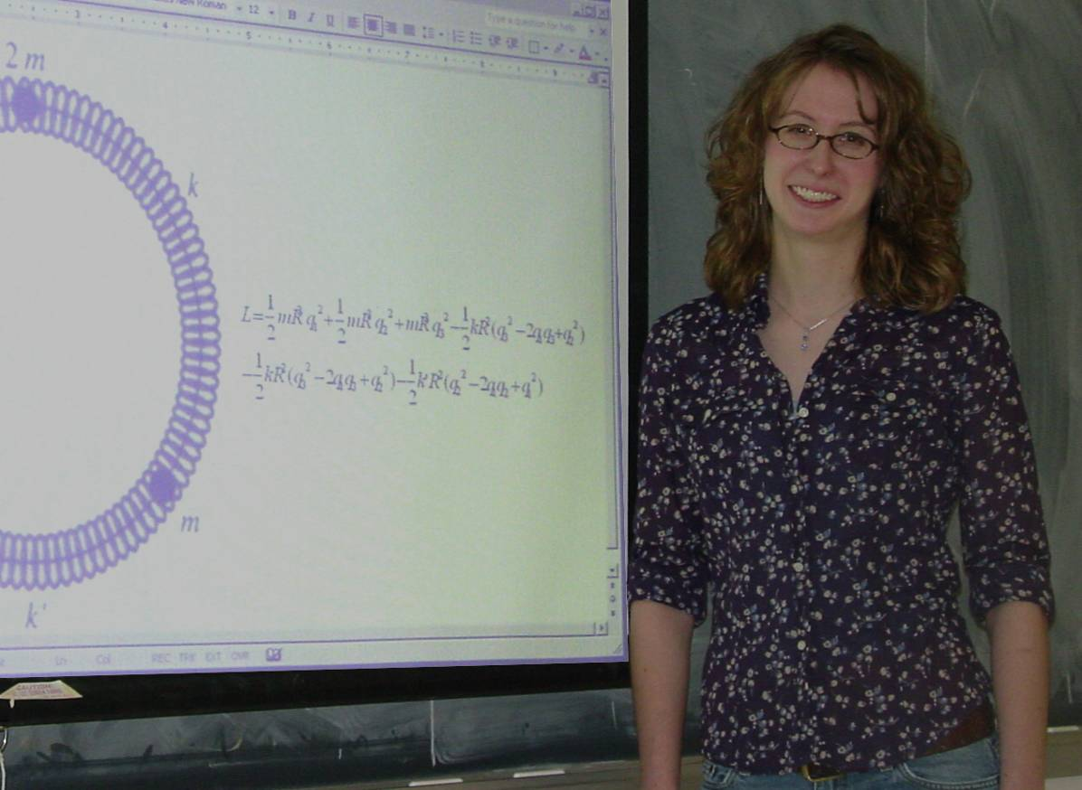
Coupled Oscillations of a Three Mass System
Lindsay Moll
Advisor: Dr. Uy
A system of coupled oscillators was studied theoretically. Normal modes, natural frequencies, and normal mode vectors were determined and explained through computation of the Lagrangian and Euler Lagrange equations and the use of K and M matrices. The system was made up of three masses attached to each other by springs with spring force constants k, k, k’ and then allowed to oscillate while confined to a circular hoop. The general case of the system was first studied. In the general case considered, the system consists of a center mass M, and two equal side masses, each with mass m. The spring constants were k, k, and k’. In the general case, the normal mode angular frequencies were found to be:
1 | 2 | 3
$$ω_{1}=0$$ | $$ω_{2}=\sqrt{\frac{k\left(2m+M\right)}{{\text{mmR}}^{2}}}$$ | $$ω_{3}=\sqrt{\frac{k+2k'}{{\text{mR}}^{2}}}$$
In the first mode, the angular frequency was zero, which means the three masses and springs moved together, with no stretch or compression. In the second mode, the two side masses moved in the same direction, opposing the direction of motion of the center mass. In the third mode, the center mass was fixed while the other two masses were allowed to oscillate back and forth completely out of phase. Angular frequencies were determined for all 16 different variations of the general case, and in addition, plots of the generalized coordinate q_{i}[t] versus time, and the generalized velocity dq_{i}/dt (i=1,2,3,…) versus time were constructed for the normal modes. Similar plots were created for a variety of cases.

