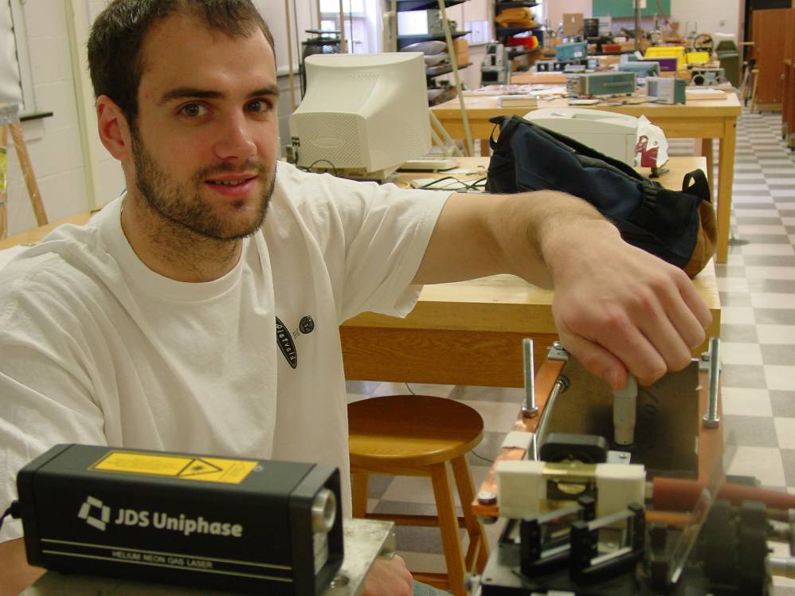
Measuring the Index of Refraction of Air
David Parks
Advisor Dr. Dooley

An optical cell is placed in one leg of a Michelson interferometer. The cell can contain a gas or fluid which, effectively changes the optical path length. The change in optical path length can be calculated from the number of fringes displaced when the content of the cell is changed. The experiment has been used to calculate the geometry of the cell two within half a wavelength and to measure the refractive index of air as a function of pressure.

To calculate the cell geometry it was filled with water. A 1mm HeNe laser beam traverses the interferometer and passes through the cell. The cell is then moved perpendicular to the optical path by a known amount using a micrometer. Fringes are displaced while the cell is moved. The number of fringes displaced was used to determine that the separation between the adjacent cell surfaces varied by 3/2 a wavelength over a vertical distance of 680um.

To measure the refractive index of air as a function of pressure a cell of known geometry is placed in the interferometer as described above. Now instead of filling the cell with water it was filled with air and then hooked up to a vacuum pump. As the vacuum pump lowers the air pressure in the cell, the optical path length is effectively changed. It was found that the refractive index varied linearly with pressure in the range of 2-100 kPa absolute. The index of refraction of air at room pressure was found to be 1.00026 +/- 0.00005.

