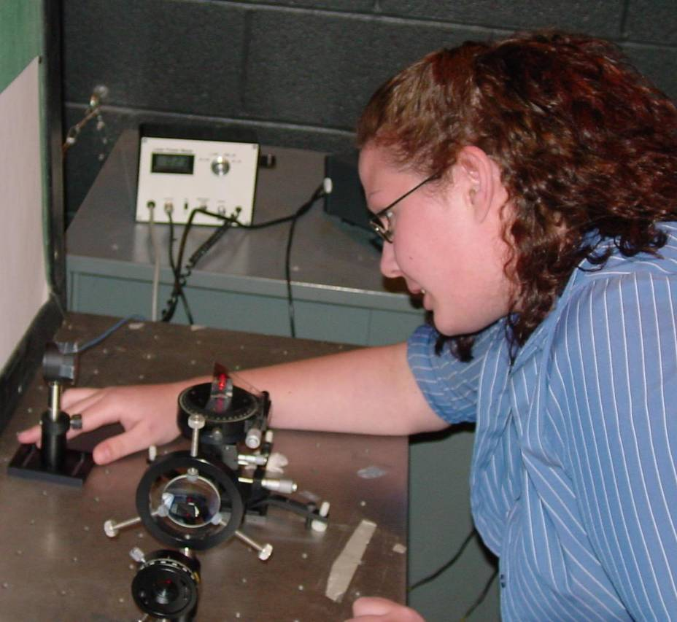

Surface Plasmon Microscopy
Leah Gallek
Advisor: Dr. Dushkina

Surface Plasmon Microscopy (SPM) is an optical method for studying very thin films that allows for analysis with much more precision than before. This technique uses a laser to generate plasmon surface polaritons or PSPs in a metal film in optical contact with a prism. The condition necessary for generating PSP’s is called a surface plasmon resonance. This occurs when plane-polarized light strikes a metal film under total internal reflection conditions. The metals used for this interaction must have a real permittivity part that is negative for the laser frequency. The noble metals exhibit this characteristic for HeNe lasers, and silver and gold are very good choices. In the experiment, there is a sharp minimum that occur in the graph of reflectivity vs. incident angle. The position of this minimum depends upon the thickness of the films. The minimum shifts from no film to different thicknesses of film can be used to determine the thickness and to “view” the thin films. SPM has advantages over other methods because as a non-contact interaction, it does not disrupt the sample.

