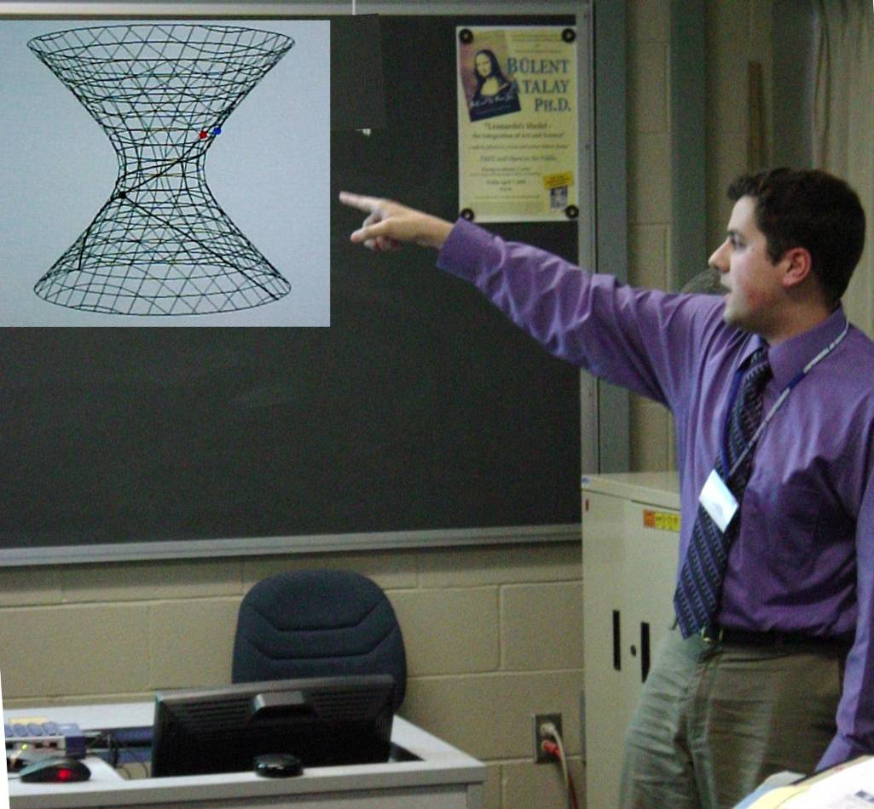
Generalizations of the Brachistochrone Problem
John Gemmer,
Advisor, Dr. Nolan

Consider a frictionless surface in a gravitational field that need not be uniform. Given two points A and B on the surface, what curve is traced out by a particle that starts at A and reaches B in the shortest time? This paper discusses studies this problem for simple surfaces such as surfaces of revolution and central force potentials. We first solve this more general problem using the Euler-Lagrange equation and conservation of mechanical energy. We then use geometrical optics to give an alternative method for solving this problem. Finally we also consider particles that are falling with relativistic velocities.

