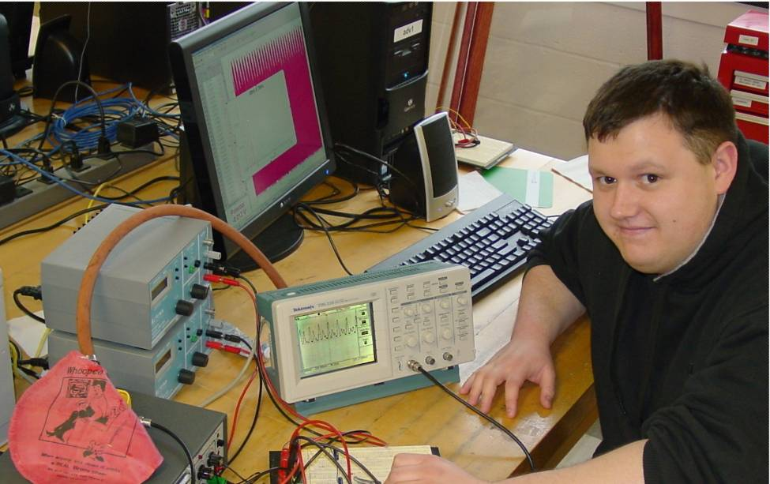

Multiphonics and Multiple Frequencies
By Paul Borst

Multiphonics is the art of being able to play more than one note simultaneously on a wind instrument. For brass players, this requires singing and playing two distinct pitches or frequencies simultaneously. The nonlinearity comes into play because more than those two notes are heard by an observer. Acoustical nonlinearity can be likened to the nonlinearity observed in a diode mixer. In both cases, the two input frequencies and their overtones add and subtract with each other to create an array of frequencies.
For this project, we first looked at the behavior of the diode mixer with two simple sine wave inputs and the interactions between the fundamental pitches and their overtone series. It was found that all of the original frequencies and overtones were present in the output as well as many additional sum and difference frequencies of the input waveforms. The original frequencies were 50 Hz, 100 Hz, 150 Hz, 200 Hz, 76 Hz, 152 Hz, 228 Hz, 304 Hz, and the resulting combination frequencies were 126 Hz, 52 Hz , 78 Hz, and 102 Hz.
Hoping to see the same effect with the trombone, we began to experiment with just how both the trombone and voice overtone series looked separately. Next, we look at how they looked combined. The combined frequency spectrum contained so many pitches that it looked like a rounded hump peaking at 170 Hz that steadily declines to 1,800 Hz. In order to determine the source of the nonlinearity, we used ear buds and speakers to drive sound through the trombone. This was not successful in creating multiphonics, therefore the source must be some aspect of the player, and not the instrument.
Recreating the act of the person blowing, we used a whoopee cushion to act as lips blow into the mouthpiece. To drive the whoopee cushion, we inserted a hose into the back of the cushion and shot compressed air into it. Unfortunately, the buzzing occurs at the neck of the cushion and not the mouth, preventing it from being able to play the trombone.

