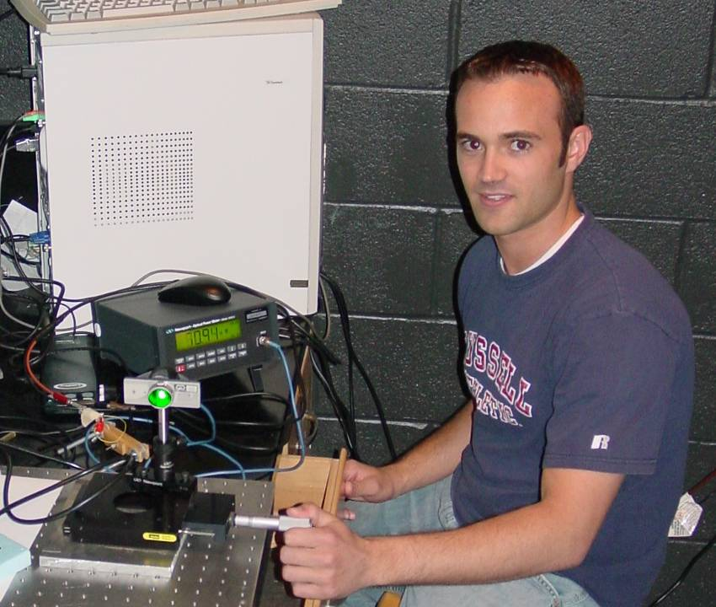

Lasers in Secondary Physics Education
Adam Hyde
Advisor: Dr. Natalia Dushkina

This research explores how a laser pointer can be used to illustrate theories of diffraction, image transformations, light intensity distribution, solid state and gas state laser physics. The experiments are meant to be simple and easily implemented into the high school physics classroom.
My first experiment used a green and red laser pointer to observe diffraction and calculate the track spacing between pits and lands of a compact disc. For the red laser pointer, wavelength (650 ± 10)nm, the track spacing d was found to be (1.58 ± 0.08)μm and for the green laser pointer, wavelength 532 nm, d = (1.55 ± 0.06) μm. These values agreed with the manufacturer’s specifications of 1.6 μm.
Lasers operating in a TEM₀₀ MODE do not have a uniform distribution of intensity within its beam. The intensity often has a Gaussian distribution, which is represented by$I(x)=I_{0}e^{\frac{−2(x−x_{0})^{{}_{{}^{2}}}}{w^{2}}}$, where x is the distance from the center of the beam, x₀ is the center of the beam (maximum intensity), I₀ is the maximum intensity and w is the Gaussian radius of the beam. I allowed the beam to expand with distance traveled and scanned across it with a narrow slit attached to a photo detector. A Gaussian fit to the plot of intensity versus position gave the measured distribution widths of (0.75 ± 0.05) mm and (0.38 ± 0.03) mm for the green and red laser pointers respectively. The quality of this relationship can be seen with the experimental data distribution being fit with a theoretical Gaussian distribution.

