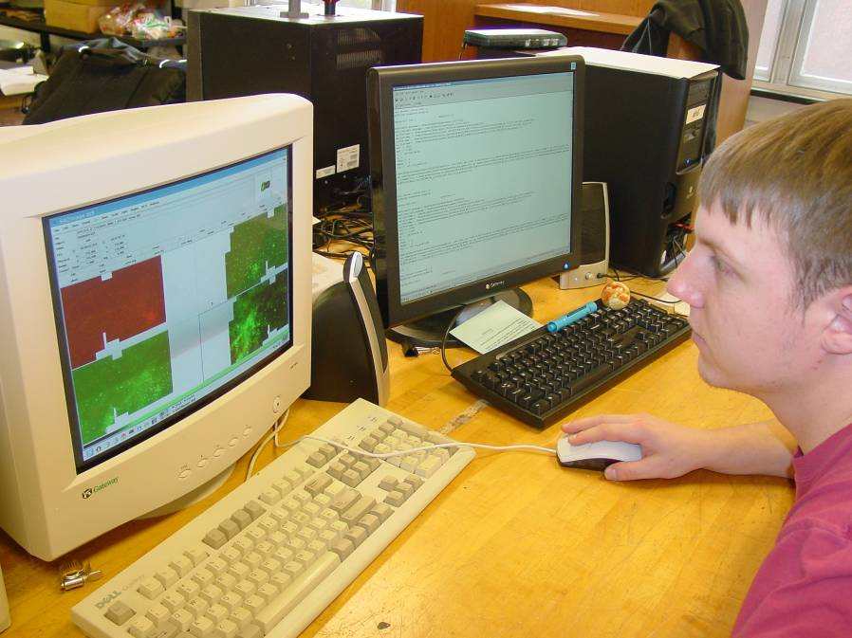

Study of Supernova Remnants Using Infrared
Matt Johnston
Advisor: Dr. Hendrick

Using infrared (IR) to study supernova remnants (SNRs) reveals the heated dust of both the shocked interstellar medium (ISM) and the dust created by the supernova explosion (SNe). The wavelength in which the dust appears is directly proportional to its energy and temperature. Data were collected in the wavelengths of 3.6-8 micrometers and 24, 70, and 160 micrometers using the Spitzer Space Telescope. These data show the thermal continuum of the SNR. By reducing the data, unwanted dust signal can be removed from the picture to show a cleaner image of the SNR. The lower temperature dust is shown at wavelengths of 3.6-8 micrometers and the higher energy dust is shown at the higher wavelengths with the highest energy dust shown at 160 micrometers.

The images of the multiple wavelengths are then combined to show a picture of the SNR with its full thermal continuum in IR. Analyses such as size and amount of dust mass in the SNR are compared to other wavelengths in the electromagnetic spectrum for an even more extensive analysis.

