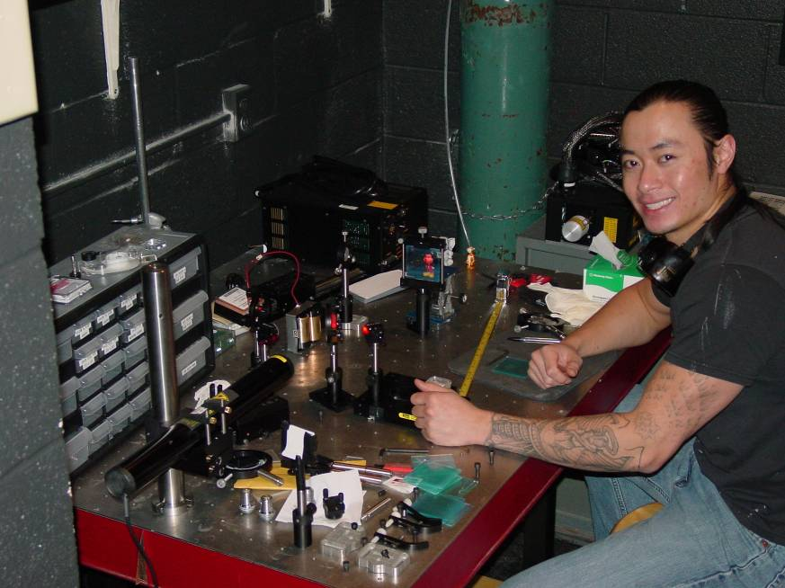

Holographic Data Storage
Long Nguyen
Advisor: Dr. Gilani

Holography is a technique of image acquisition where information regarding light’s amplitude as well as phase is captured, as opposed to the amplitude alone, as in the case with photography. This allows for recreation of the original object’s image, with all the same properties, such as depth and parallax, as if viewing the object itself. This technique can be applied to acquisition, storage, and access of information; of particular interest, is the potential of increased storage capacity. This is achieved by creating volume holograms within a thick photosensitive media The phenomenon of Bragg Selectivity allows for multiplexing holograms within the same volume. Several holograms were made, including double exposure holograms using two different angles for the reference beam, as proof of concept for the storage of multiple data sets in one object.

