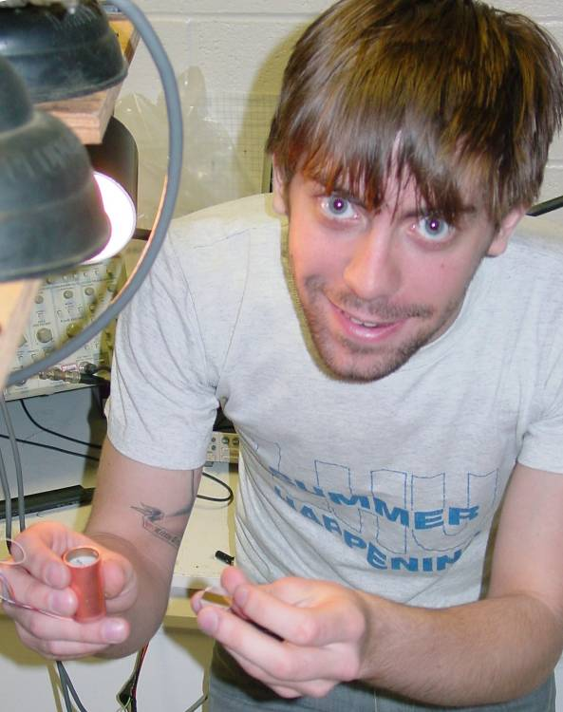
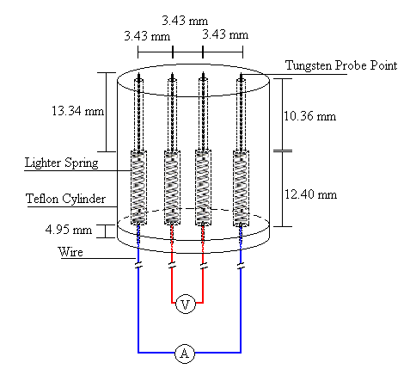

Conduction in Nano-Engineered Thin Films at Cryogenic Temperatures
By Andrew Jones
Advisor: Dr. Tariq Gilani

The conduction mechanism in sculptured thin films is currently an interesting field of study for physicists. With a cold cup made on site we used the linear 4-point probe method to measure the resistance (and therefore the conductivity) of sculptured thin films at temperatures ranging from 6 – 200 K. We tested both chromium and gold thin films. Both showed the expected linear temperature dependence between room temperature and about 50 K. Below 50K, all samples, including a brass foil, showed an anomalous peak, followed by a non-linear temperature dependence.

