

Sonoluminescence
By Michael Kreider
Advisor: Dr. Mehmet Goksu

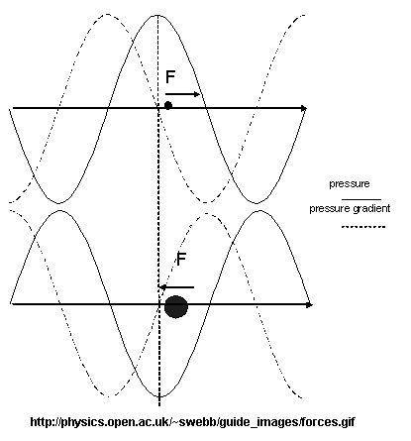 Sonoluminescence occurs when a small air bubble is rapidly compressed and expanded in the anti-node of a standing ultrasonic wave. In the right combination of bubble constants, size, water temperature, amplitude and frequency of sound, the bubble can be induced to emit light. No light has been observed.
While what occurs inside the glowing bubble is highly debated, the mechanics of what takes place outside the bubble is simpler to some extent. The equilibrium position of the bubble is calculated by balancing the buoyancy force vector, the gravitational force vector, and the average pressure gradient force vector.
The pressure gradient force is greater on the drop when the pressure is low, because the volume of the drop is greater then. This leads to the bubble equilibrium position near the pressure amplitude maximum.

