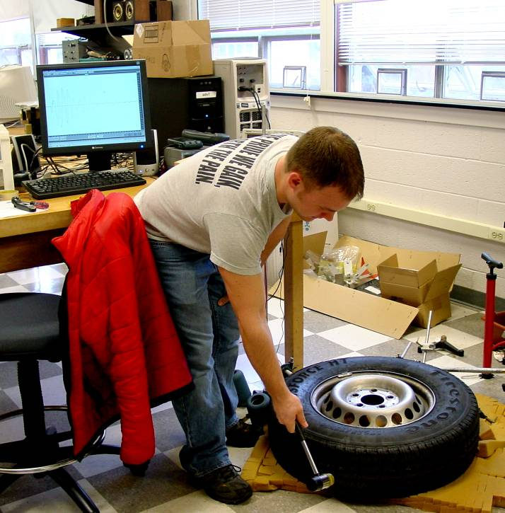

Normal Vibrational Modes of a Truck Tire
Cody Borigo
Advisor: Dr. John Dooley
The objective of this research is to identify and understand the normal vibrational modes of a truck tire in order to determine if tire failure could be predicted by monitoring these vibrations. Vibrational data was collected by striking the tire and recording vibrations via a microphone. The vibrational data was then broken down into its constituent frequencies via Fourier analysis. Several factors have been analyzed including resonance, absorption, effect of pressure change, and the effect of loading the tire with additional mass. Several phenomena have been identified, including a 200 Hz vibration that can be attributed to a circumferential wave in the air cavity, two dominant and related frequencies near 100 Hz that depend strongly on pressure and could be due to Stoneley waves, and an absorption frequency that is also highly dependent on pressure and responsive to mass loading, which may be attributed to the “breathing mode” of the tire.

