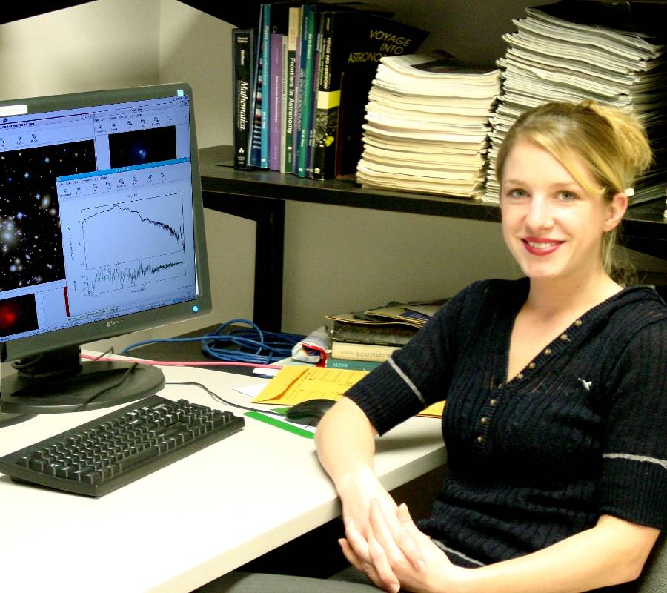

X-ray Observations of the Galaxy Cluster Abell 4059
Erin J. Magagna
Advisor Dr. Sean Hendrick
Galaxy clusters are among the largest objects in the universe. They are filled with hot, diffuse plasma that emits x-ray radiation. This project presents the examination of dark matter and its existence in galaxy clusters. Dark matter is currently undetectable by direct observation; however, it can be identified by its gravitational affect on visible matter. Archival data of galaxy cluster Abell 4059 was used in this study. It was observed with the Chandra X-ray Observatory on three separate occasions; 2000 September 24, 2001 January 4, and 2005 January 26-27. The distance is 226 Mpc away with a radius of 0.207 Mpc. A spectrum was extracted and fit with a model that assumes the plasma is in thermal equilibrium. Its plasma temperature was found to be $3\text{.}{\text{61}}_{−0\text{.}\text{08}}^{+0\text{.}\text{07}}$ keV. X-ray gas emission and the basics of galaxy clusters are also reviewed in this paper. The virial theorem can be applied to astronomical objects that have a gravitationally bound spherical distribution of mass and are in equilibrium. It states the kinetic energy is equal to the negative of one half of the potential energy, so the total mass of the system can be determined. This virial, or total, mass of Abell 4059 was calculated to be $3\text{.}{\text{35}}_{−0\text{.}\text{074}}^{+0\text{.}\text{065}}{\text{x10}}^{\text{13}}$ solar masses. Mass distribution and density of the x-ray gas are examined as a function of radius. The sum of the masses of these regions results in the total mass of the x-ray gas which is found to be larger than the combined mass of the galaxies in the cluster. The difference between virial mass and the mass of the x-ray emitting gas demonstrates the existence of dark matter within the cluster. Results show the mass of the x-ray gas is 2.47 x 10¹² solar masses, therefore leaving 3.10 x 10¹³ solar masses of dark matter.

