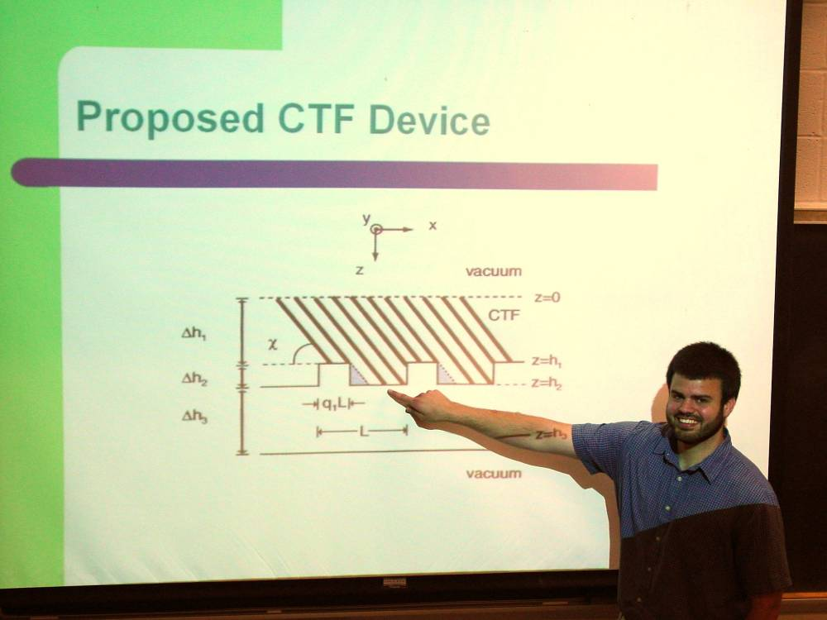

Spectral Calculations for Columnar Thin Films Deposited on a Periodically Decorated Substrate

Jon M. Mease

Advisor: Dr Tariq H. Gilani

Using a morphological model of a class of nano-engineered materials called columnar thin films (CTFs) deposited on periodically decorated substrates, we compute their optical reflection and transmission spectra. The deposition geometry and the spatial periodicity affect the spectra in technologically significant ways. Our current efforts are focused on a narrowband, linear-polarized rejection filter. The calculation procedure involves the use of the MIT Electromagnetic Equation Propagation (MEEP) software libraries. The accuracy of MEEP was initially verified by calculating the reflection and transmission spectra of several simple scenarios for which analytic solutions are obtainable. Then MEEP was applied to a unique proposed device that consists of CTFs deposited on a periodically decorated substrate.

