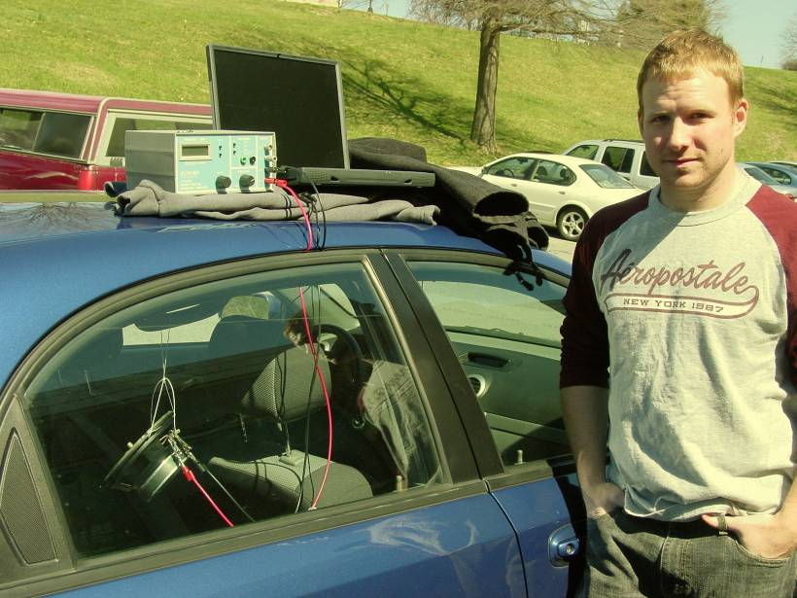

Observation of Car Window Resonance
Darren P. Scott
Advisor: Dr. John Dooley

Resonant harmonic frequencies occur on a daily basis. For my research, I have decided to examine the resonant harmonic frequencies of an automobile cabin and also examine the ways in which these frequencies may be driven. The most common type of driver is using an air stream while driving the car. By measuring the dimensions of the vehicle, I was able to calculate the Helmholtz frequency to be 47 Hertz. I was also able to calculate the standing wave frequency, of a tube open at both ends, to be 117 Hertz. I found the resonance of the cabin experimentally by hanging a loudspeaker in the car and I tuned the frequency. The experimental frequency was 46.2 Hertz. Another possible way to drive the harmonic system would be to drive the car down the highway with the rear windows open. This is very similar to the physics of a flute. The frequency measured with both the back windows down was 19 Hertz. I also observed a linear velocity dependence of the resonant frequency amplitude. There was also a threshold speed for the resonance of 40 miles per hour. If I record the resonance in stereo I noticed a phase shift of the pressure waves, yet this is still inconclusive.

