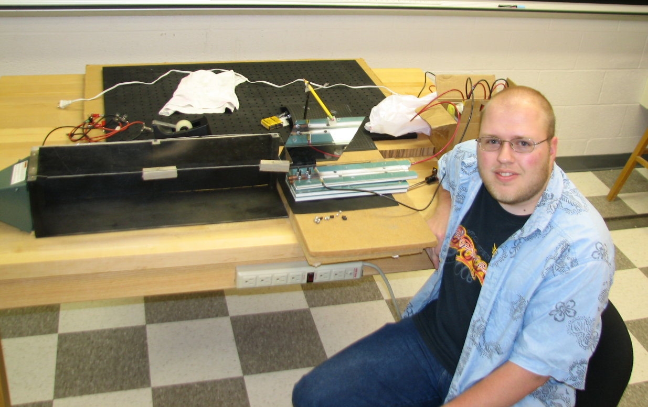

The Efficiency and Conservation of Energy in a Railgun

Paul Folmar

Advisor: Dr. Tariq Gilani

ABSTRACT

A railgun is an electromagnetic accelerator that can fire projectiles at great speed. From observing the railgun, the conservation of energy can be seen. With the use of a high speed camera, the kinetic energy can be calculated and compared to before and after firing, and the efficiency of the railgun determined. The maximum efficiency achieved was 0.28% where .053±.014J of 192J was transferred into kinetic energy. From this it was concluded that the majority of the energy is transferred into heat energy from the discharge of the capacitors.

