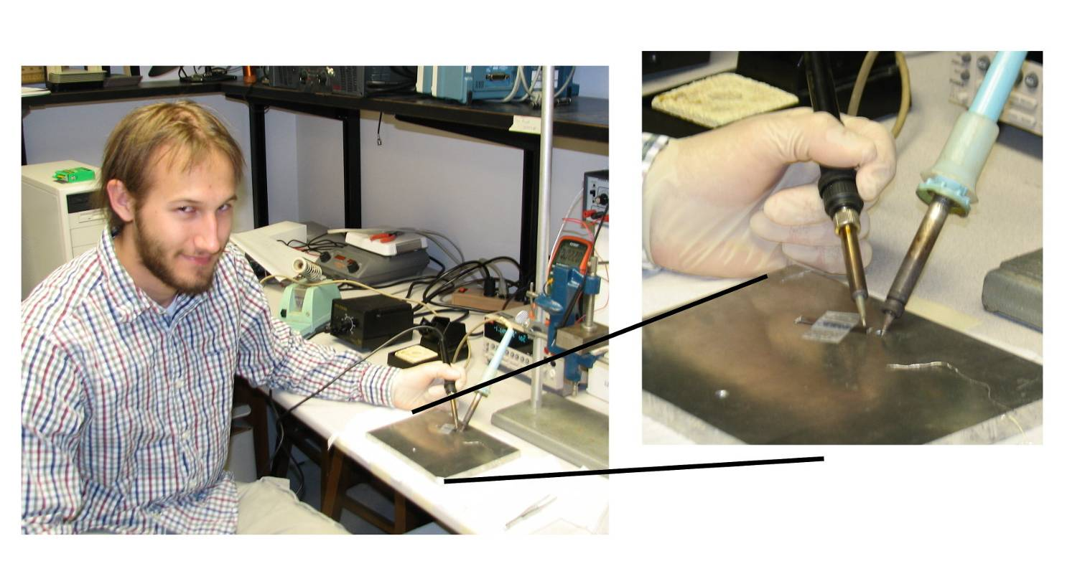

Studying Seebeck Effect

Michael Oellig

Advisor: Dr. Mehmet Goksu

ABSTRACT

We studied thermoelectric characteristics of metal alloy and doped silicon thermocouples. We measured Seebeck coefficients of metal alloy, n-type and p-type silicon at different doping concentrations in the temperature range of 295 and 315 K. We observed similar Seebeck coefficients and temperature dependence for the same kind of silicon materials. We also measured electrical conductivity of the semiconductor materials and then determined the charge carrier density and ZT factor that is used as a measure of enhancement of the thermoelectric properties of semiconductor materials.

