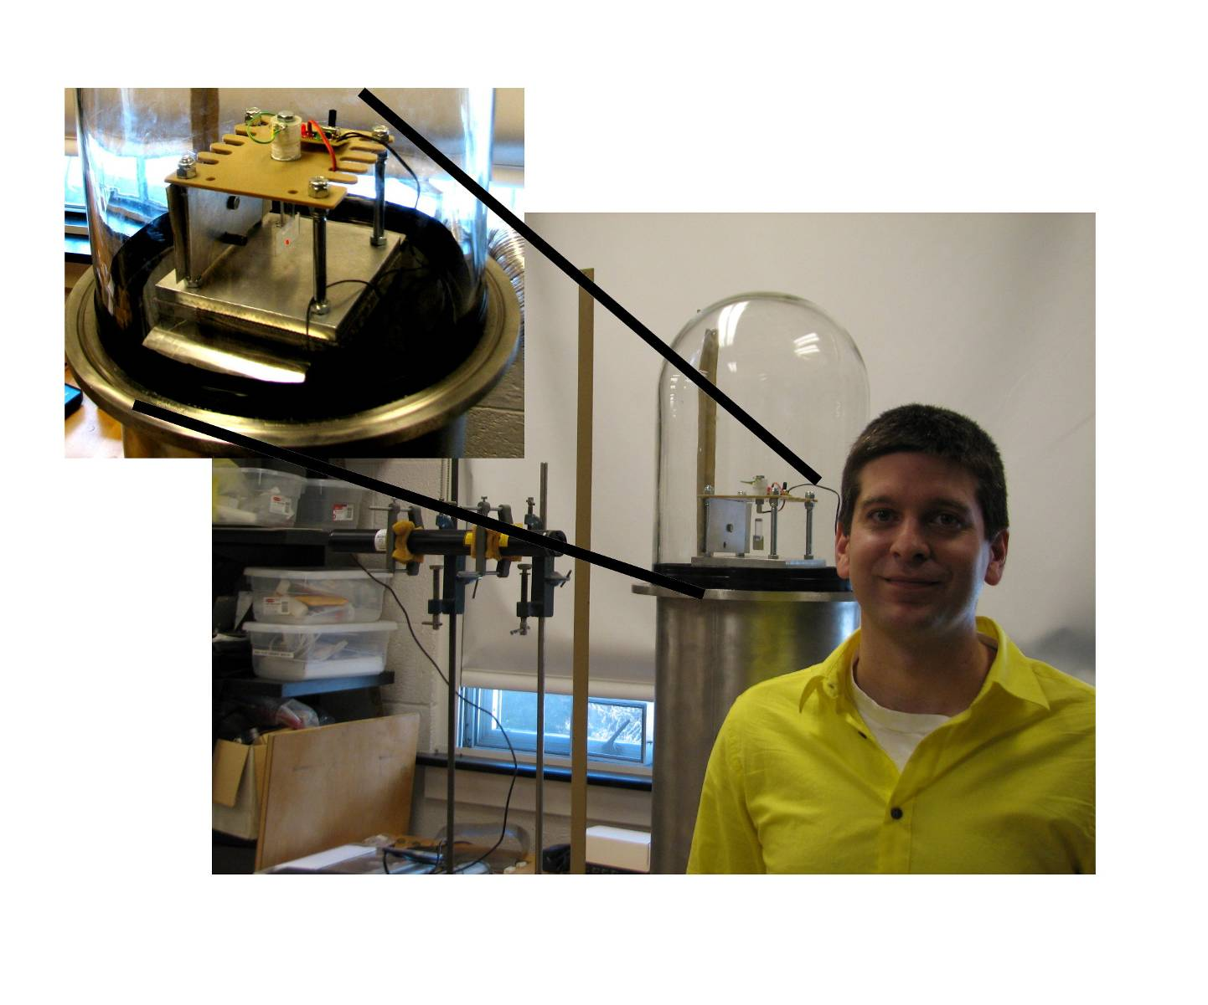
MEASURING THE FORCE OF LIGHT

Joshua York
Advisor: Dr. John W. Dooley

Abstract: This study presents a method for measuring the force light exerts on an object. A light source is directed onto a mirror that is magnetically levitated so that it will recoil in response to the force of the photons. By measuring the rotational response of the mirror assembly, the force is calculated. In order to minimize thermal effects due to energy dissipation in the form of heat, this experiment is performed under a vacuum. The force of a 19.1mW laser was measured to be (5.87$±$2.65) x10⁻¹¹ N at a pressure of 10⁻⁵ torr. The expected value of the force of the laser is (8.20$±$0.07) x10⁻¹¹ N with 91.6% of the light transmitted through the glass of the vacuum chamber, 45.1% reflected by the mirror, and 4.6% transmitted through the mirror.

