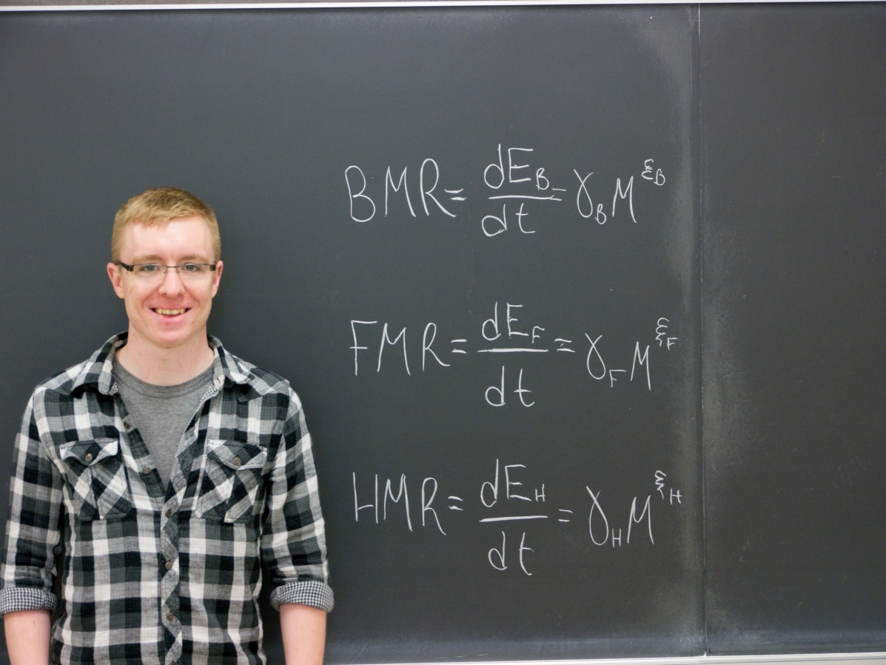
Optimal Foraging Principle Based on Metabolic Rates
of Lions and Tigers
Sean Forsyth
Advisor: Dr. Christopher Nelson

In ecology, there are several models that explain the allometric relations between metabolic rates and body mass. The principle metabolic rates involved are the BMR (Basal Metabolic Rate), FMR (Field Metabolic Rate) and the HMR (High Metabolic Rate). I have worked along side of Dr. Christopher Nelson to develop a method that calculates the certain correlations between the average times the animal spends in each of the energy rates, the body mass, the time spent in the field metabolic rate, and the allometric quantities. This research was performed specifically on Bengal Tigers, Serengeti Lions, and African Wild Dogs. The research is used to take the already known metabolic rates and compare them to the model to support the idea of natural selection acting as a “filter” to choose specific metabolic rates in nature.

