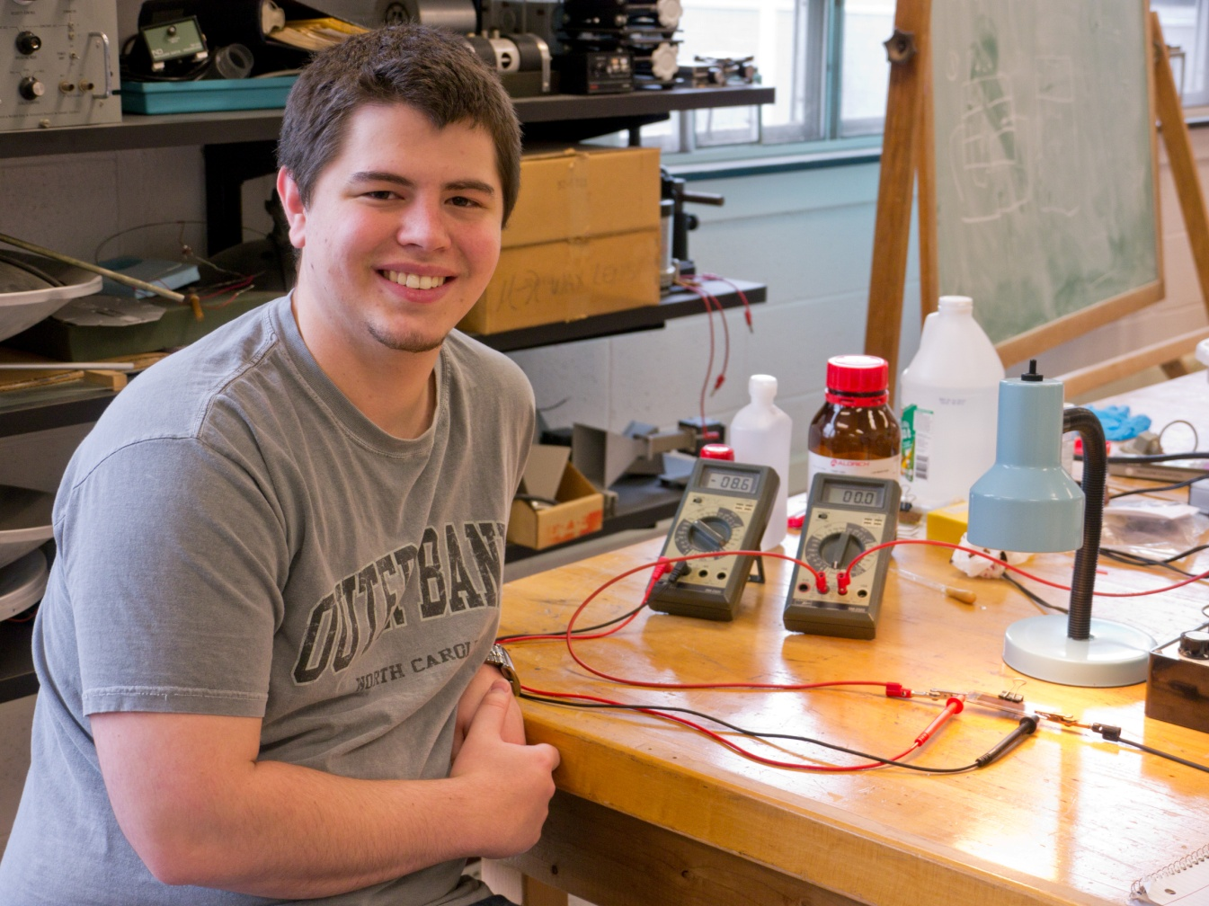

Dye Sensitized Solar Cells
Daniel Heck
Advisor: Dr. Mehmet Goksu

This research is being conducted to determine the feasibility of a dye-sensitized solar cell. Making a dye-sensitized photovoltaic cell is a new technique that provides an economically cheaper and technologically credible alternative to the current solid state cells in use today. The cells will be tested in a number of ways to find if this new technology is truly a possible alternative.

