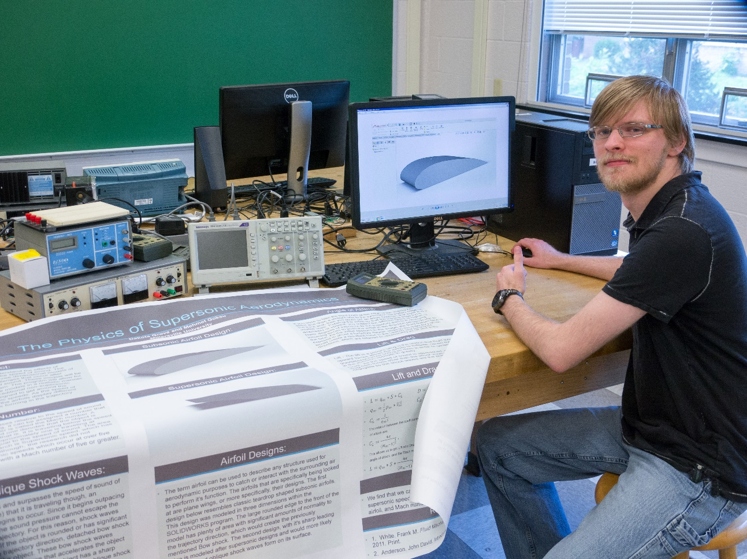
The Physics of Supersonic Aerodynamics
Dakota Grove
Advisor: Dr. Mehmet Goksu
The purpose of the research was to examine and explore the additional forces encountered by an object as the object reaches and exceeds the speed of sound within air. As an object nears this speed, pressure changes occur as shock waves form between the free stream air and the object. These changes to pressure causes an altered resultant net force that can cause insurmountable drag in objects with ill-fitting geometric designs. The primary topic of the research was how the modified geometry of a supersonic airfoil allows for the circumvention of bow shock waves that form at supersonic speeds for subsonic designs. The use of blade-like airfoil designs allows instead for the formation of connected oblique shock waves that caused significantly less drag. In the research, we find how to relate the forces that appear in supersonic aerodynamics to physical characteristics of the airfoil design and its speed.

