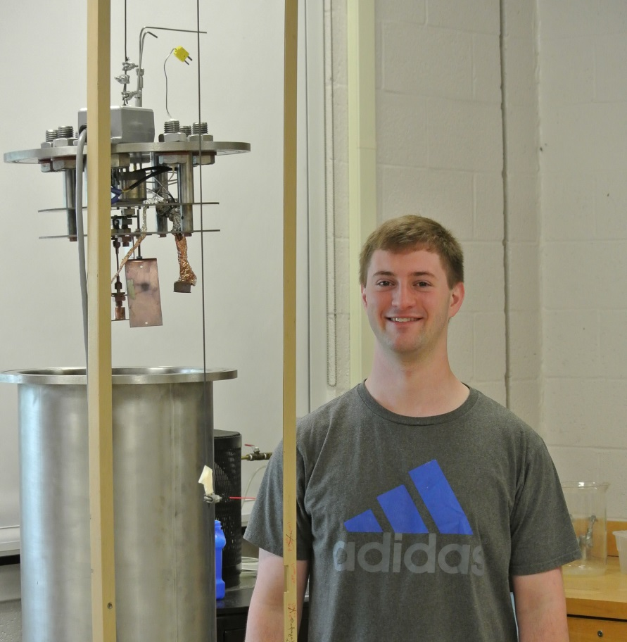

Columnar Thin Films as Gas Sensors
By Daniel Long

Advisors: Dr. Tariq Gilani and Dr. Natalia Dushkina

Sculptured Thin Films (STFs) are nanostructured materials with spatially varying properties that can be designed by controlling Physical Vapor Deposition (PVD) variants. Columnar Thin Films (CTFs), a subset of STFs, are comprised of parallel nano-columns with void space throughout the film. CTFs are fabricated by Glancing Angle Deposition (GLAD) or Oblique Angle Deposition (OAD) in a vacuum chamber with a fixed angle of incidence and controlled substrate temperatures. Due to the porous nature of CTFs, gaseous species can diffuse throughout the film, causing changes to its electromagnetic properties such as its relative permittivity. A process which is sensitive to changes in relative permittivity is Surface Plasmon Resonance (SPR). SPR is the oscillation of valence electrons at the interface between two materials where the real part of the dielectric function changes sign across the interface. When a Surface Plasmon(SP) is excited, a sudden drop in reflection intensity is observed in the experimental setup from coupling of the incident light to the SP. Porous gold films of less than 170 nm thickness were fabricated and SPR was performed in various moisture content environments.

