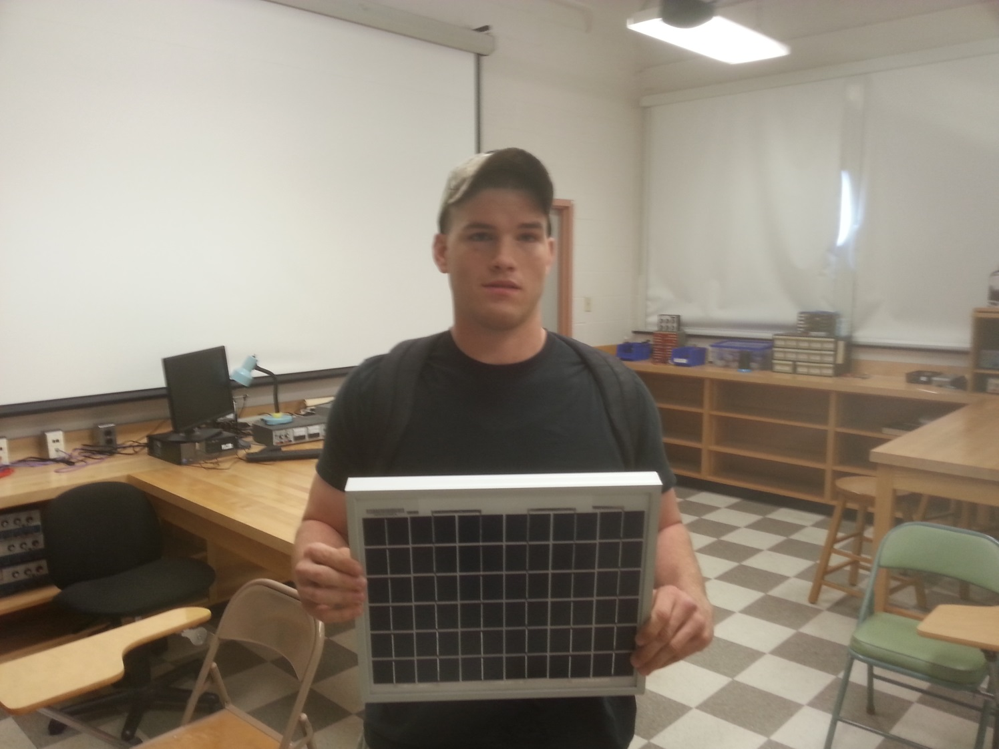

Photoelectric Effect and Applications

Daniel Cox
Advisor: Dr. Mehmet Goksu

The purpose of this experiment was to further investigate the photoelectric effect and one of its applications in the use of photovoltaic (PV) cells. Through these different experiments I analyzed the characteristics of two different solar cells. Also, I determined how monochromatic light affects the incident intensity and energy along with the output power of a solar cell. As well, I examined how different intensities of light affected the operation of the cell. I then evaluated how operating temperature affects performance and efficiency of a silicon photovoltaic cell. Also, through graphical analysis I determined that a photovoltaic cell operates less efficiently at higher temperatures. In addition, through the use of six different monochromatic color filters I was able to graphically display the transmitted incident lux and output power of the Tycon solar cell per color of parts of the visible spectrum.

