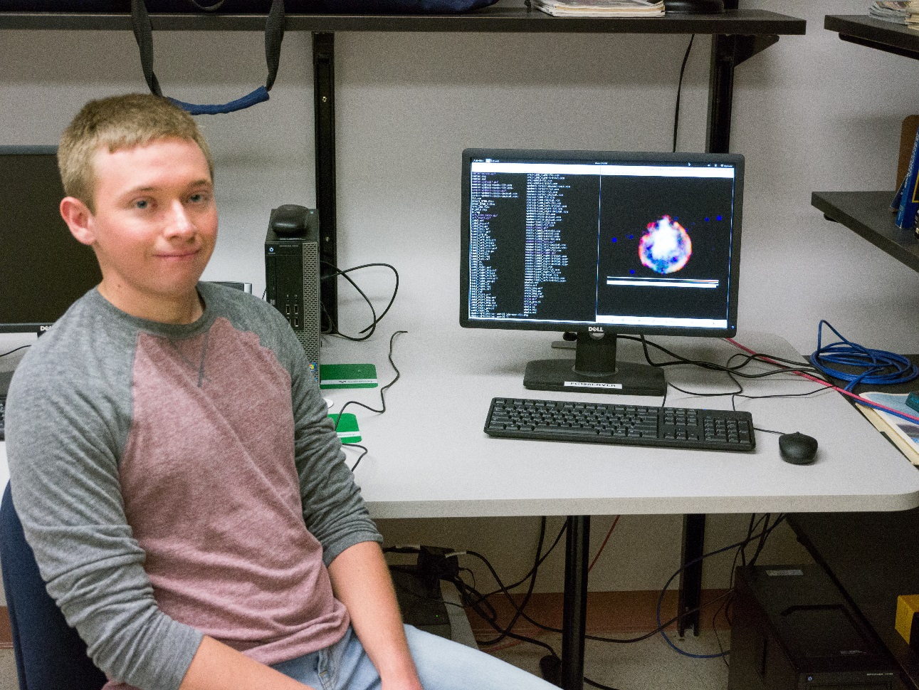

X-ray Analysis of SNR 0103-72.6 in the SMC

David Doerr

Advisor: Dr. Sean Hendrick

Supernova explosions (SNe) are the extremely energetic deaths of certain stars. Supernovae are defined by the presence, or absence, of particular spectral lines in their initial spectrum: H, He, and Si. They are further classified by the mechanism of the explosion. The possible mechanisms are the gravitational core collapse of massive star or the thermonuclear detonation of a White Dwarf in a close binary system. Supernovae are responsible for the creation of heavy elements in the universe with each mechanism creating slightly different abundances. Supernova remnants (SNRs) all go through evolutionary stages starting from the ejecta-dominated phase to the Sedov-Taylor phase and finally to the radiative phase. SNR 0103-72.6, located in the Small Magellanic Cloud, has been observed in the past using the Chandra X-ray Observatory. The morphology of this remnant shows a central region of ejecta emission and a clear outer limb region dominated by swept up interstellar medium (ISM). Using the CIAO software package and NASA’s XSPEC software, data was prepared and models were fit for various regions of the remnant. Values for shock velocity, remnant age, energy, and swept up mass were calculated. The remnant appears to be around 5,000 years old with a shock velocity of around 1,800 km/s.

