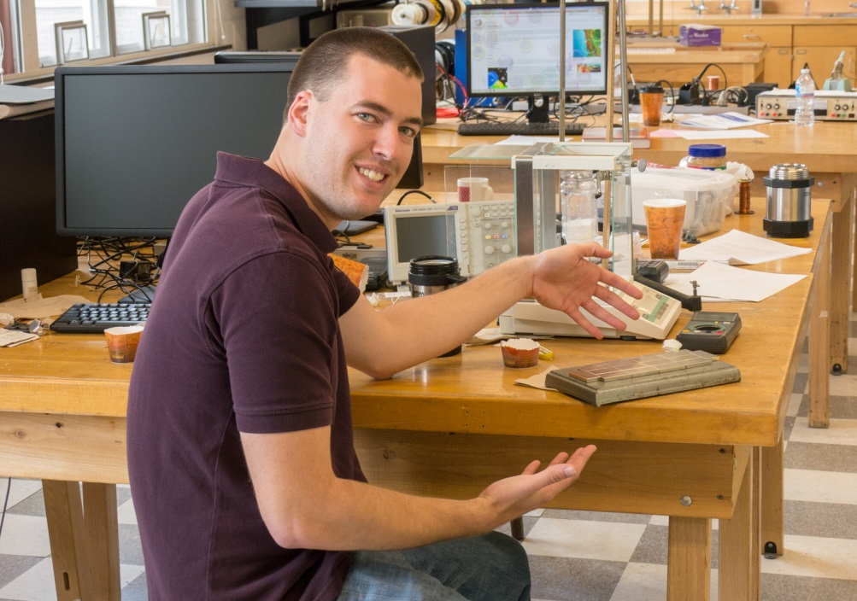
Quantum Levitation (2013)
Eric Miller

Advisor: Dr. Mehmet Goksu

Quantum Levitation is a physics phenomenon dealing with how superconductors act when placed inside of a magnetic field. Superconductors are specific elements and compounds which have two states of being which are divided by a specific temperature called the critical temperature. When the superconductor is above its critical temperature, it is said to be in the normal state. However, when it is cooled below its critical temperature, it goes into the superconductive state. All critical temperatures are very low (in comparison to room temperature) and therefore even the highest temperature superconductors must be cooled with at least liquid nitrogen. While in the superconductive state, the superconductors attain two additional properties that they do not have while they are in the normal state: they have an electrical resistance of zero and they expel all applied magnetic fields.
There are two types of superconductors, type I and type II. However, only type II superconductors are able to attain quantum levitation because they have a third state of being called the mixed state. This is attained when a magnetic field is applied that has a strength that is between two critical magnetic field values. While in this mixed state, the superconductor is partly in the normal state and partly in the superconductive state. The part in the superconductive state then expels the magnetic field and the part in the normal state allows the magnetic field to pass through. This creates areas called flux vortexes (areas where strands of the magnetic field move through). These strands are called fluxons. The fluxons do no work unless the superconductor moves through 3 dimensional space. So in order for the superconductive parts of the superconductor to have an electrical resistance of zero, it locks itself in place 3 dimensionally, and that is how we are able to attain quantum levitation.

