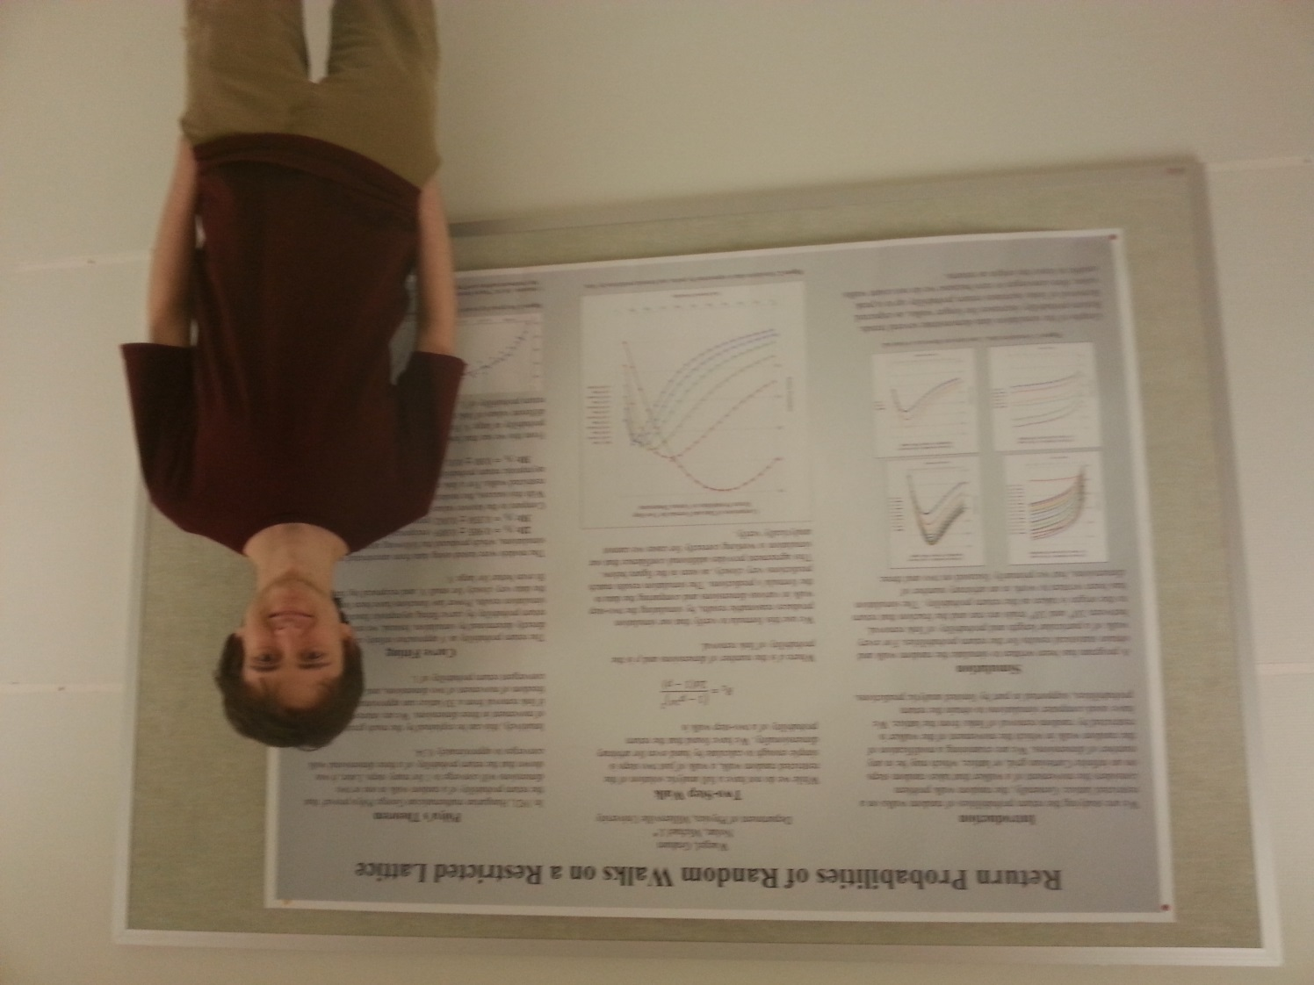
Return Probabilities of Random Walks on a
Restricted Lattice

Graham Waegel
Advisor: Dr. Michael J. Nolan

In this project, we are examining the return probabilities of a modified random walk, in which the movement of the walker is restricted by random removal of links from the lattice that the walker is traversing. This restriction of movement alters the walker's probability of return to the origin, based on the probability of link removal. The nature of this relationship is explored using computer simulations which are partially checked against a limited analytic solution. Asymptotic return probabilities for walks of many steps are found by fitting models to simulation data. The maximum asymptotic return probability for the three dimensional restricted walk was found to be 0.87±0.02, occurring when the link removal probability is 0.75.

