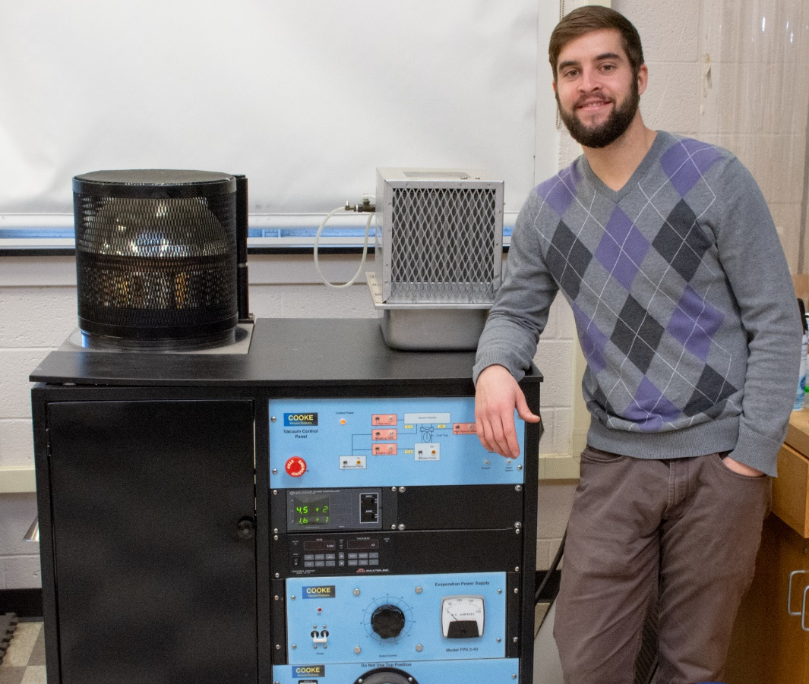

Resistivity of Silver Thin Films
Ken Brubaker
Advisor: Dr. Tariq Gilani
The purpose of this research is to investigate the electrical properties of Silver Thin Films (TF). The focus is on the resistivity as a function of thickness of the Silver TF. The Silver TFs of various thicknesses ranging from 7 to 90 nm were prepared by evaporating 99.999% pure Silver onto glass substrate. The electrical resistivity was measured using 4-probe method. The results of electrical resistivity vs thickness of the Silver TF are presented here. Experimental data shows the resistivity depends on the thickness of the TF. When thickness becomes smaller than the mean free path of the charged carriers, anisotropic scattering occurs. The surface roughness of the TF also plays an important role in determining the scattering of conduction electrons.

