This procedure, which is meant to simplify requisition input, should be completed before you enter your first requisition and whenever any updates and/or changes are needed (change in accounting information, move to a different department, etc.). This setup is only to be used as a guide, feel free to set this area up in a way that will work best for you.

In the SAP system, go to ME51N - Create a new Purchase Requisition.

Click the Personal Setting icon.
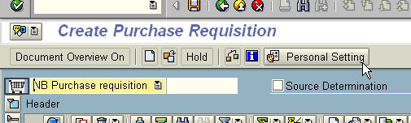

The first Tab is the Basic settings:

Change the Selection timeframe for my docs. To No restrictions, and make sure each area has a check mark.

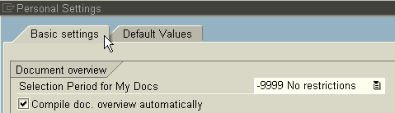

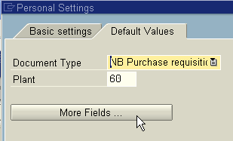
Click the Default values tab.

Click the More Fields icon.

The goal in this area is to move items from the Hidden fields to the Display fields to set default values that will be populated when you create a requisition.

Continue moving the fields on your screen so that your Display fields area matches the one on this page.To save your information click the Copy icon at the bottom of the page.

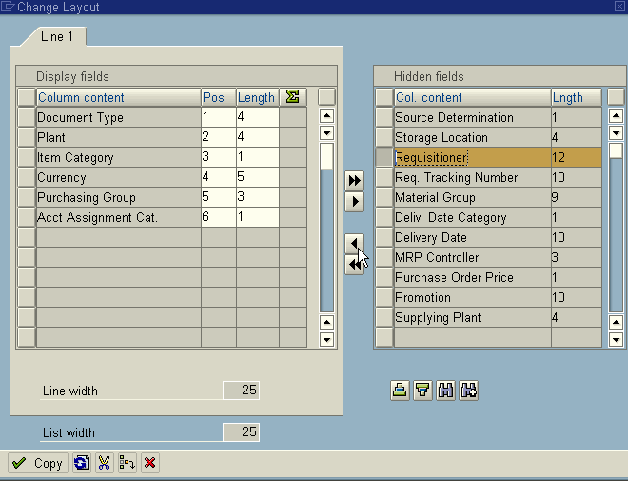

You are now back at the Default values area where the personal settings will be entered.

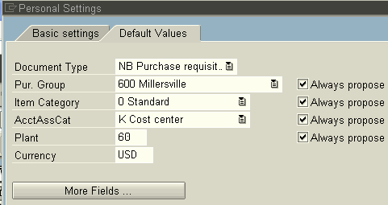

Type the default values as appropriate, make sure there is a check mark in the Always propose block.

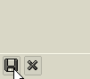

When all the fields are entered click the Save icon at the bottom on your screen.

After the Save icon has been clicked and you are back on ME51N Create Purchase Requisition the default fields will be populated. Remember, the default information can be changed in the individual Purchase Requisition document, if needed.

