Registration Guide
Summer/Fall Semester 2026


Registrar’s Office
1st Floor – Lyle Hall
Hours - 8AM-4:30PM Monday-Friday
Phone – 717-871-5005
Fax – 717-871-7894
Email – Registrar@millersville.edu

What is this Registration Guide?
This Registration Guide explains registration (how, where, and when to enroll in courses) as well as information concerning the drop/add and withdrawal processes, special registration procedures and many other aspects surrounding the registration process that you may find useful.
Note: all the referenced page numbers on this document are links directly to the portions of the Registration Guide that the page number is referring to. Just click on the page number!
It is the responsibility of all students to be familiar with the announcements, deadlines and regulations of the university printed in this booklet and in the General Catalog. Information herein is subject to revision.
E-mail is an official means of communication from Millersville University to ALL Millersville students. All Millersville students are responsible for activating and managing their university-assigned email account and accessing all information sent to their university-assigned email account.
Contents
Important Dates & Deadlines 4
SUMMER 2026 4
FALL 2026 4
Summer 2026 Online Drop/Add & Withdraw Deadlines 5
Fall 2026 Online Drop/Add & Withdraw Deadlines 5
Registration Basics 6
Student Responsibilities 6
How do I register? 6
When do I register? 6
Registration credit limits 6
Registration holds 7
Term Advisement Holds 7
Academic Advisement 7
Degree Audit Reporting 7
Course Cancellation/Change Notifications 7
Getting in a Closed/Restricted Course 8
Special Registration Procedures 8
Notes for Education Majors 8
Notes for Newly Incoming Transfer Students 8
Notes for Transient Students 8
Withdrawal/Leave of Absence from MU 8
Leave of Absence (Undergraduates Only) 8
Military Leave of Absence 8
Graduate students and Leave of Absences 9
Withdrawing from the University (Undergraduates Only) 9
Graduate students Withdrawing from the University 9
Registration & Students with Special Needs 9
Student Self-Service 10
SEARCH WEB SCHEDULE 11
BROWSE COURSE CATALOG 12
PLAN AHEAD 14
VIEW REGISTRATION INFORMATION 16
PREPARE FOR REGISTRATION 17
REGISTER FOR CLASSES 18
WAITLISTING 23
Waitlist Information 25
Waitlisting Details and Procedures 25
Waitlisting FAQs for Students 26
Registration Error Messages 29
Permission to Enroll Forms 30
Special Registration Procedures 36
Auditing a Course 36
Franklin & Marshall Exchange 36
Taking a Course Pass/Fail 36
Course by Examination 37
PASSHE Visiting Student 37
Independent Study 38
Individualized Instruction 38
Cooperative Education/Internships 38
Registration Tips 39
Drop/Add & Withdrawal Procedures at MU 40
Information for Summer 40
Information for Fall 2026 41
Registration Preparation Checklist 42
Major Department and Program Contacts 43

Important Dates & Deadlines
The dates below concern registration and related activities ONLY. Please check the Academic Calendar on a weekly basis for a complete list of academically-related events and deadlines. At least once a week, access the Registrar’s Website to see if there are any important registration announcements listed under News. These are your primary means of finding timely information about registration activities as well as other important information.

SUMMER 2026
February 10th – Undergraduate and degree-seeking graduate student registration begins at 9 AM EST. Waitlisting for courses begins with registration – notifications for open/available seats will be active with 24 hour notice.
February 13th – Graduate non-degree student registration begins at 9 AM EST.
May 11th – Summer Session Begins
Deadlines to drop/add and withdraw from Winter courses will vary by class. See the sections on Drop/Add & Withdrawal Deadlines (pg 6) for more details.
Contact the Registrar’s Office at 717-871-5005 for details regarding deadlines to take a course pass/fail or on an audit basis during the Summer term.

FALL 2026
April 7th – Degree-seeking graduate student registration begins at 6 AM.
April 8th – Graduate non-degree student registration begins at 6 AM.
April 9th-17th – Undergraduate registration begins. See the Appointment Schedule on the Registrar’s Website for detailed information. Waitlisting for Fall courses begins and notifications for open/available seats will be active with 48 hour notice.
August 20th – Students who receive email notification for an open seat will have 18 hours (reduced from 48) to respond through MAX.
August 24th – Classes begin; late registration online; drop/add period begins online.
August 31st – Last day to drop or add a course online (by 11:59 PM EST).
September 1st – Withdrawal period begins (See the sections on Drop/Add & Withdrawal Procedures (pg. 40) for more details); last day to submit a request to take a course on a pass/fail or audit basis (requests must be in the Registrar’s Office by 4:30 PM)
October 30th – Last day to withdraw from a course & receive a W grade (online withdrawal form must be submitted to faculty by the end of day)
December 7th – Last day to change a pass/fail grade to a regular grade
December 12th – Fall term ends
Fall deadlines listed are for standard length courses. For non-standard length course deadlines, see the sections on Drop/Add & Withdrawal Deadlines (pg 6) for more details.

Summer 2026 Online Drop/Add & Withdraw Deadlines

The deadline to drop/add or withdraw from courses in the winter or summer sessions varies on the start and end date of the course. Please see the applicable link below for more details:
Drop/Add and Withdraw | Millersville University
Please refer to the Office of Student Accounts website for information on the Winter refund and the Summer refund policies.

Fall 2026 Online Drop/Add & Withdraw Deadlines

The deadline to drop/add or withdraw from most courses in the spring and fall semesters can be found on the appropriate academic calendar.
If you are registered for a course that begins and/or ends earlier or later than the standard semester, these deadlines will vary. Please see the link below for a listing of these courses and the deadlines attached to them.
Drop/Add and Withdraw | Millersville University
Important note: if you are registered for a course that begins later in the spring/fall semester and wish to drop it before the deadline, please email registrar@millersville.edu with the request.
Please refer to the Office of Student Accounts website for information on the Fall/Spring refund policy
Undergraduate students that withdraw from their last class in spring or fall MUST complete withdraw or leave of absence paperwork.

Registration Basics
MAX is Millersville University’s Web-based registration system. You can add or drop courses, place yourself on the waitlist for courses and perform many other functions, including viewing your Degree Audit report.

Student Responsibilities
You are responsible for confirming your registration and making any changes by the designated deadlines. It is your responsibility to drop unwanted courses and to confirm that they have been dropped from your schedule. You cannot depend on being dropped from a course due to nonattendance or for nonpayment.
It is also the responsibility of all students to be familiar with the announcements and regulations of the university printed in this booklet and in the General Catalog. Information herein is subject to revision.

How do I register?
Registration takes place online through MAX, Millersville’s online registration system. When you can register for classes (see When do I register below) you can register for classes through the MAX system. See page 10 for more details regarding logging in and registration through the MAX system.

When do I register?
Check the Important Dates and Calendars section (pg 4) of this guide for the beginning dates of registration for Millersville’s academic terms.
The actual beginning registration time for undergraduate students for Summer, Spring & Fall semesters vary based on number of credits earned and the first letter of their last name. See the Appointment Schedule on the Registrar’s Website for more information.
It’s highly recommended that you utilize the Registration Preparation Checklist and Schedule Planning Grid located at the end of this registration guide to make sure you are prepared for registration and that the courses you’re planning on taking fit your schedule!
Note: Missing class to register is not an excused absence and is not acceptable!

Registration credit limits
Spring & Fall - Undergraduate students are limited to registering for 18 (see note regarding Students on Academic Probation below). Undergraduate students may not go above 18 credits until the first week of classes (drop/add); those students seeking to do so must contact the Registrar’s Office and should expect additional fees due to a credit overload. Contact the Office of Student Accounts at 717-871-5101 for information regarding these additional fees.
Winter & Summer – Undergraduates in Winter & Summer are limited to 7 & 8 credits, respectively. A form, which must be signed by the student’s academic advisor, can increase these limits. Please visit the Registrar’s Office in Lyle Hall for a copy of this form.
Students on Academic Probation – If you are currently on academic probation, you are limited to 13 credits during the Spring and Fall terms. A form, which must be signed by the student’s academic advisor, can increase this limit. Please visit the Registrar’s Office in Lyle Hall for a copy of this form.

Registration holds
A hold may be placed on your record for a variety of reasons. Clearing holds before your registration appointment will save you time and frustration. It is your responsibility to view your record on MAX to see if you have any holds on your account. You can view your holds by logging into MAX, and choosing Student Services > Student Academic Records >View Holds.

Term Advisement Holds
All undergraduate students are required to see their academic advisors to register for the fall or spring terms. Your academic adviser will remove your registration hold during the advisement period. Entering transfer students, newly readmitted students and students coming off a leave of absence are exempt from having a registration hold their first semester at Millersville (or, in the case of readmitted students or students returning from a Leave of Absence, their first semester back at Millersville). However, these students are required to have their advisement hold removed by their advisors in subsequent semesters. Graduate students are not required to have a TAP.

Academic Advisement
Regardless of whether you have an advisement hold (see above), you should contact your advisor or major department chair for advisement on what courses you should be taking. See this page for a listing of department chairpersons. The Registrar’s Office cannot offer academic advisement. You can see who your academic advisor is by logging into MAX, and clicking on Student Services > Advisement > Advisers.
If you are a graduate student, please see your program coordinator for academic advisement.

Degree Audit Reporting
The degree audit is a software program that matches a student's course work for the current, active program with the degree requirements for a particular major curriculum at Millersville and provides a detailed report, or degree audit, summarizing the completion status of each requirement. The degree audit lists not only the requirements that must be completed in the program, but also the status of degree candidacy and other degree requirements such as cumulative credits and GPA.
Your degree audit report can assist you with knowing what to schedule; you should always have a copy on hand when you meet with your academic advisor.
You can access your degree audit report by logging into MAX. Please see the Registrar’s Website for in-depth details regarding DARS.

Course Cancellation/Change Notifications
If a course you have been registered for has been cancelled or the location/time of the course has been changed, you will be notified of the change through your Millersville Marauder email account.

Getting in a Closed/Restricted Course
The instructor and/or department of the course you are attempting to get into may provide you with an override during registration. Please see the Permission to Enroll Forms section (pg 30) for more information on the forms that are required for these overrides. Remember that you MUST still register for the course on MAX after you’re given an override!

Special Registration Procedures
Please see the section on Special Registration Procedures (pg 36) regarding instructions for Auditing courses, taking a course on a Pass/Fail basis, the Franklin & Marshall Exchange program and other procedures.

Notes for Education Majors
See here for information regarding Elementary and Secondary Foundations Bloc, Secondary Professional Bloc, APS (Advanced Professional Studies) and Student Teaching.

Notes for Newly Incoming Transfer Students
If you are a newly admitted transfer student who is currently taking courses at another institution, one or more of which would fulfill prerequisite requirements for a course you are trying to register for, please contact the Registrar’s Office for assistance.

Notes for Transient Students
If you are a transient student who is attempting to register for a class that is currently unavailable to you, please contact the Registrar’s Office for assistance.

Withdrawal/Leave of Absence from MU

Leave of Absence (Undergraduates Only)
Students who wish to interrupt their studies at Millersville for up to two consecutive semesters may request a leave of absence.
This allows them to register for courses upon their return without applying for readmission. To be eligible for a leave of absence, a student must be enrolled in degree status and have a minimum CGPA of 2.00.
To request a leave of absence, complete an official Leave of Absence Form, available online here. Contact the registrar’s office for information on the effects of a leave of absence. Note: For MEDICAL Leave of Absences, contact the Registrar’s office for further details.
Students who take a leave of absence to study at another institution during the fall or spring semester should also complete an Authorization for Transfer of Credit form, available from the registrar’s office or on the web. A leave of absence is cancelled, and the student considered withdrawn, if the student fails to return by the established ending time or is dismissed by the University.

Military Leave of Absence
Students who are called to active duty must contact the registrar’s office for assistance with arranging a leave of absence and their subsequent return to the University. A copy of the student’s military orders must be presented to the registrar. Students who expect to return to class within the current semester to complete their course work, or who are called to duty after completing a significant part of the course requirements, should contact their faculty regarding missed work. Students who cannot complete the current semester will be granted a leave of absence for military duty and will be allowed to return for the next semester without penalty.

Graduate students and Leave of Absences
Graduate-level students (both degree and certification seeking) are given a five year window in which to complete their program. A leave of absence for a semester or two is not necessary.

Withdrawing from the University (Undergraduates Only)
Students who wish to withdraw from the University must complete an Official Withdrawal Form, available from the Registrar’s Office or on the Millersville website in the Student Forms Center. This applies to all students, whether withdrawing during or between semesters, regardless of reason for withdrawal. Failure to complete this form will jeopardize a student’s chances of future readmission. Note: For MEDICAL Withdrawals, contact the Registrar’s office for further details.
Students who have officially withdrawn from the University and wish to return should contact the Admissions Office, Lyle Hall, for an application for readmission. Contact Admissions for more information (717-871-4625).

Graduate students Withdrawing from the University
If you are a graduate student looking to withdraw from the university, please complete the official withdraw form on the Graduate Student Forms webpage.
Please contact Graduate Studies for more information and details (717-871-4723).

Registration & Students with Special Needs
If you have learning and/or physical disabilities and need special accommodation concerning registration, please contact the Office of Learning Services for information (717-871-5554).

Student Self-Service
Registration
The Student Self-Service application in Banner 9 allows students to view registration information in one location.
Contents
Search Web Schedule
Browse Course Catalog
Plan Ahead
View Registration Information
Prepare for Registration
Register for Classes
Waitlisting

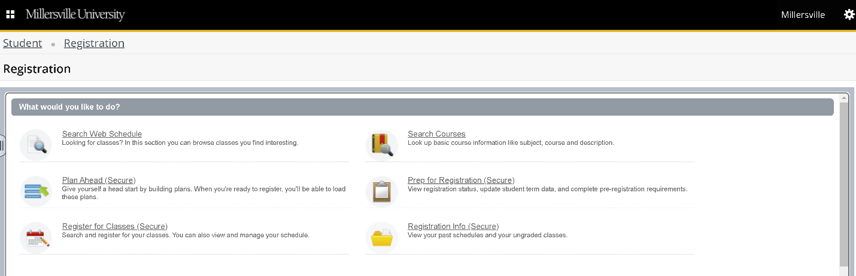

SEARCH WEB SCHEDULE

Find classes - basic search.
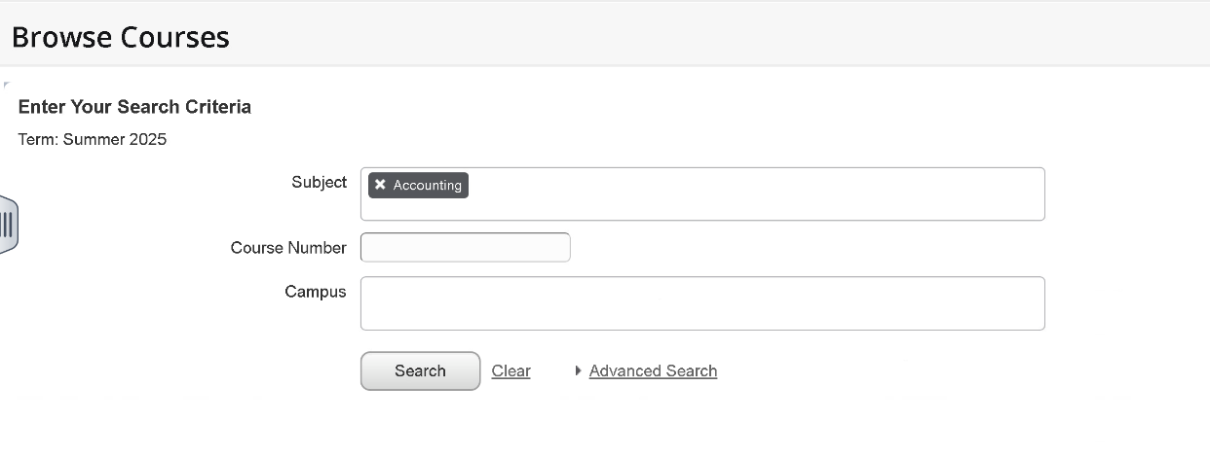
Find classes - advanced search
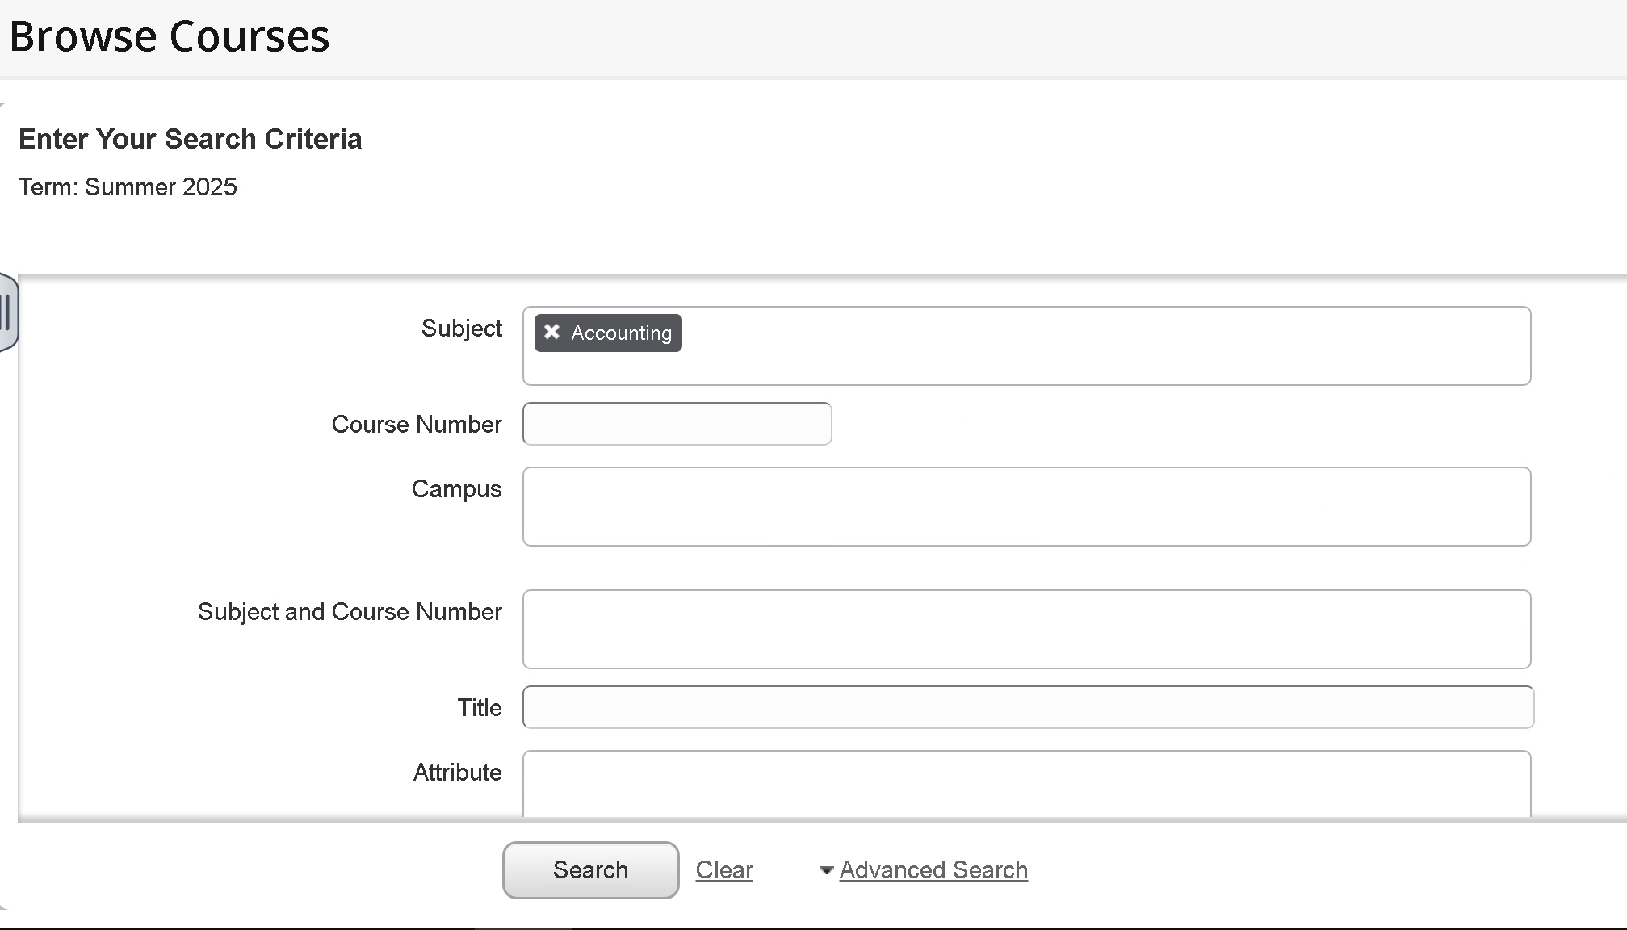

BROWSE COURSE CATALOG

Basic search
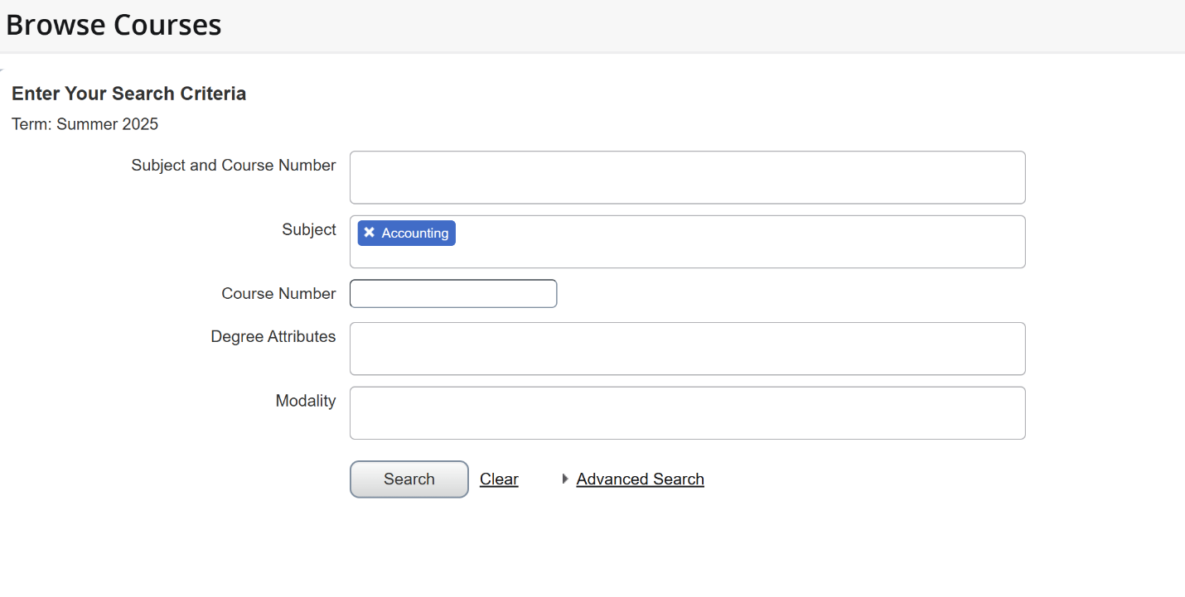Advanced search
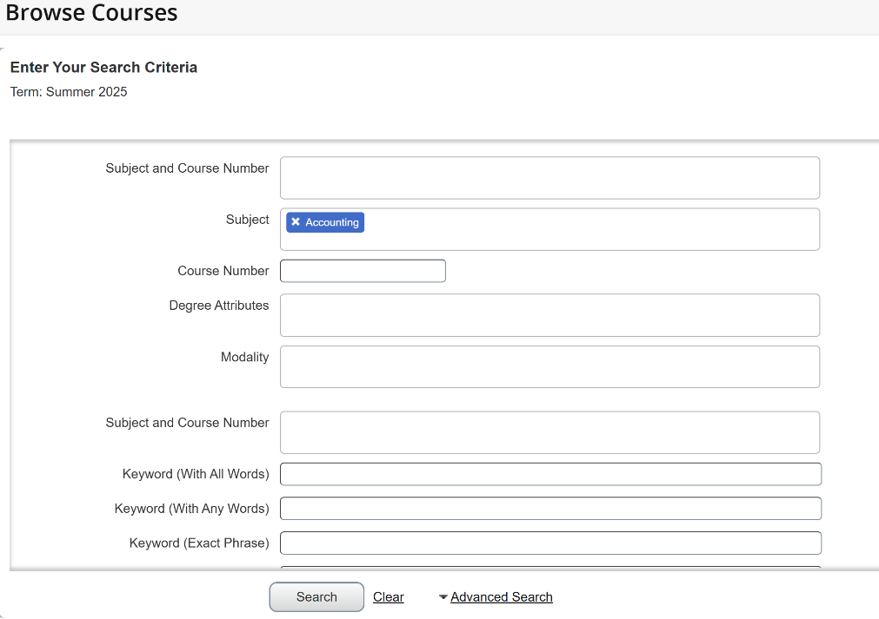

You can view course information by selecting the title and section information by selecting the view section button on the right.
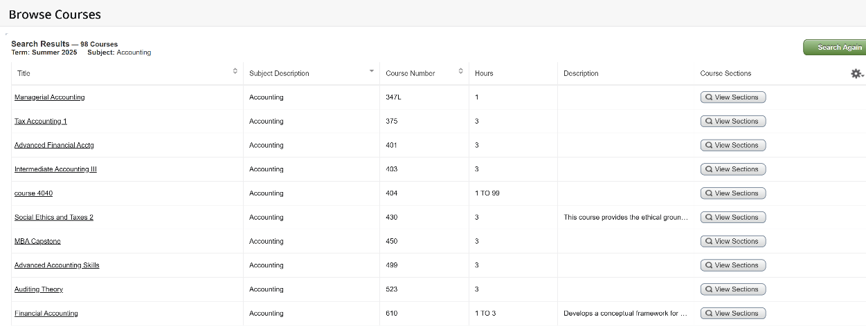
Course details:
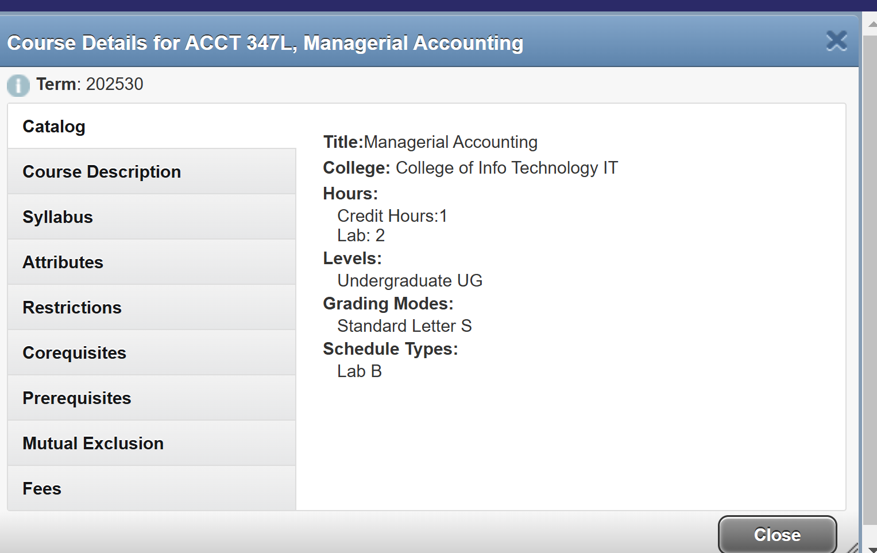
View sections
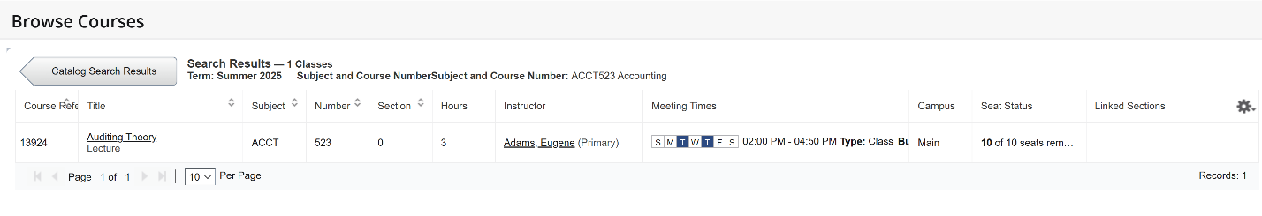
*Please note that not all courses in the catalog will have section results, as they are term based.

PLAN AHEAD

You can have up to 10 plans per semester.
That can include a plan from your advisor.
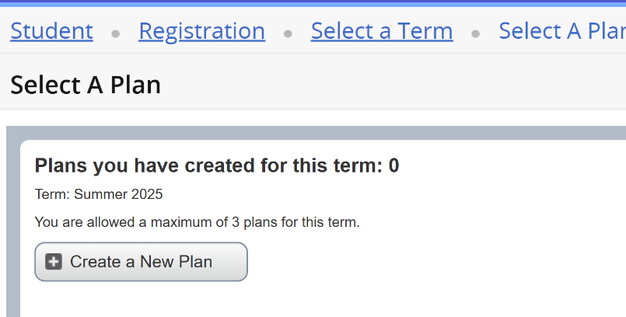
Search for your courses using a basic or advanced search.
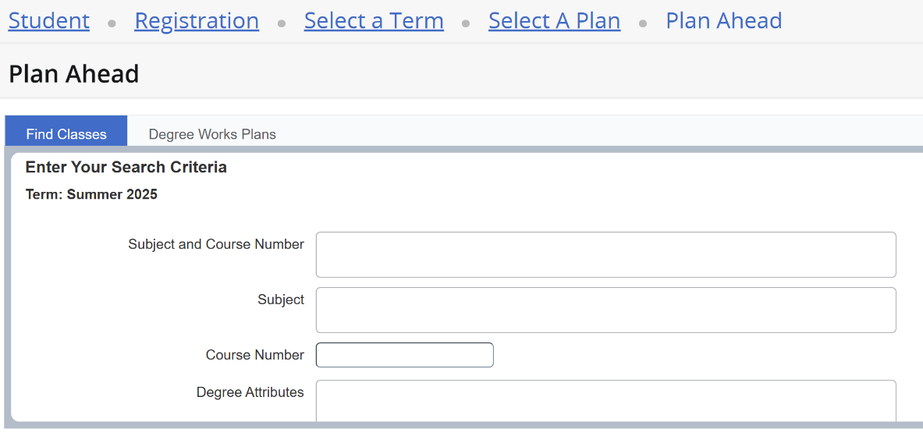
The plan page shows the search tool, schedule, and summary.
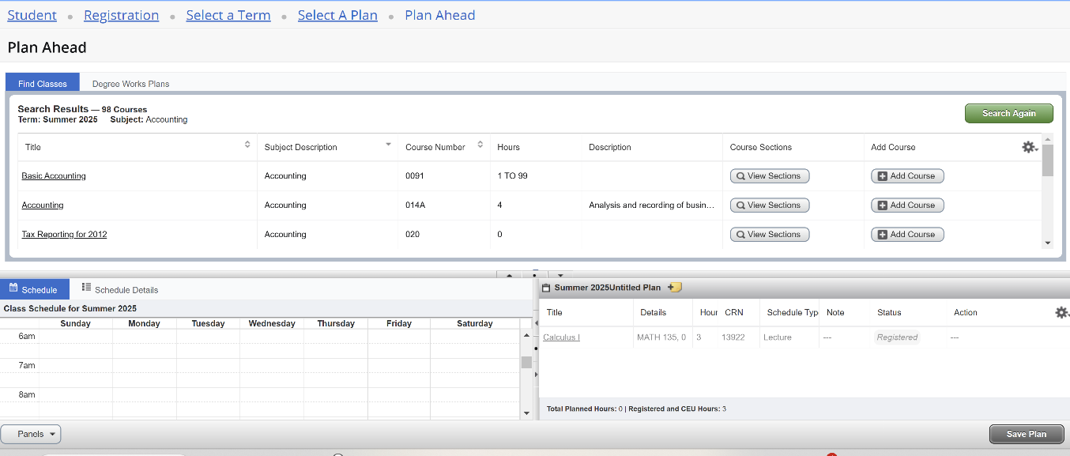
The results allow you to navigate the sections, course details, and add courses to your plan.
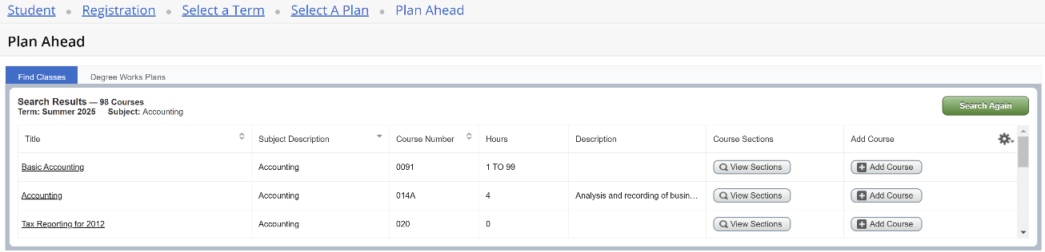
Selecting the title will give you the course details.
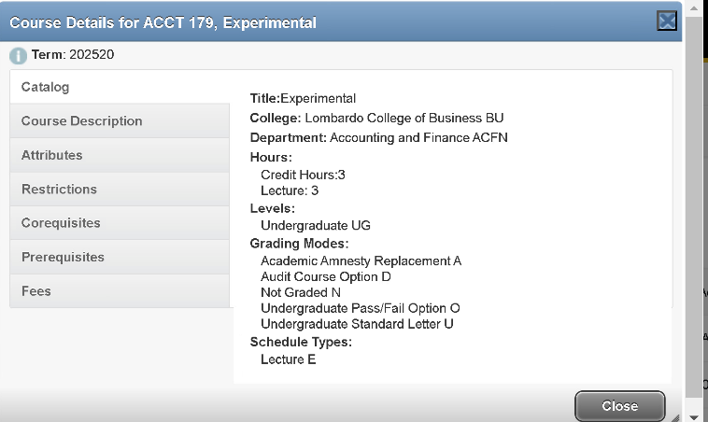
View section information:
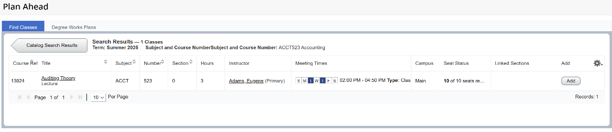
Once you find the course you want to register for you can add it to your summary in the bottom right. Then save and name your plan. You can also make notes on each course selection. 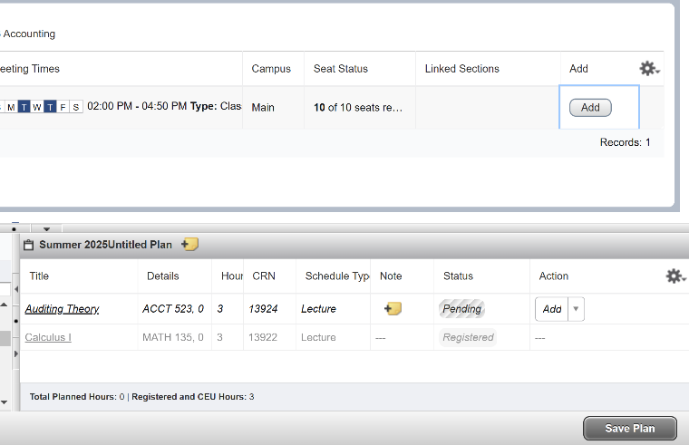 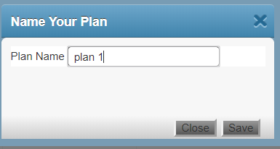

VIEW REGISTRATION INFORMATION

You can view your past registration, weekly schedule, and schedule details.
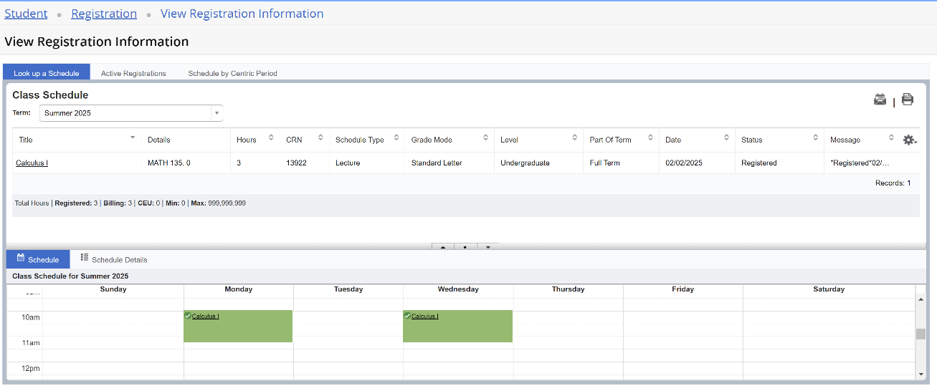
You can also view your active registration.
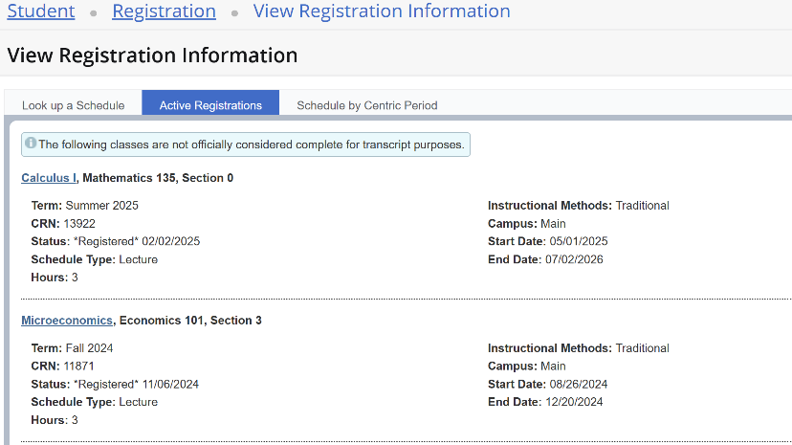

PREPARE FOR REGISTRATION

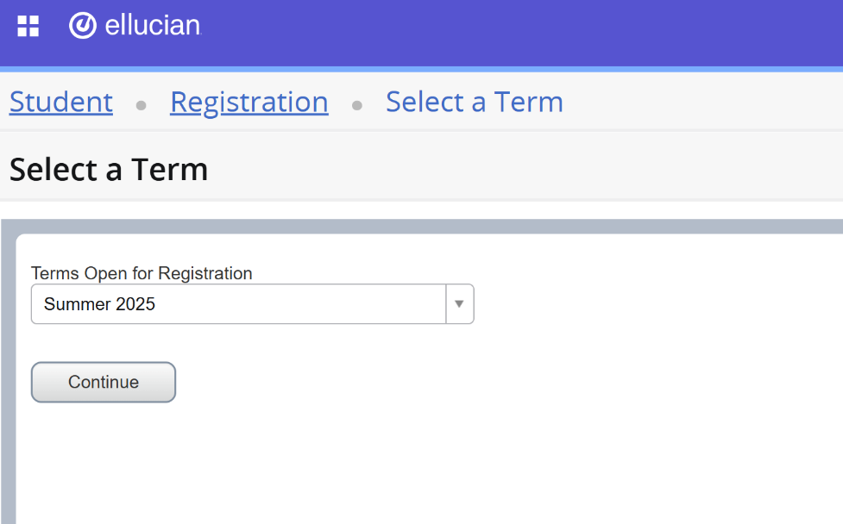

Select a term for registration using the drop down.

Registration status page:
Student status Holds
Academic status Earned hours
Class standing Curriculum
Curriculum Permits

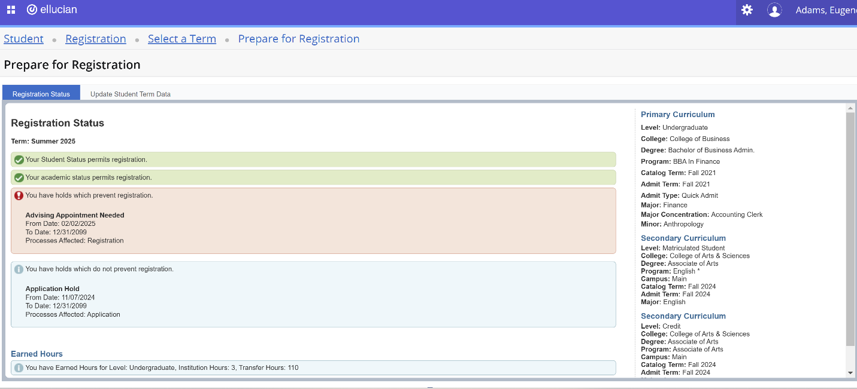
Holds, red blocks registration

REGISTER FOR CLASSES

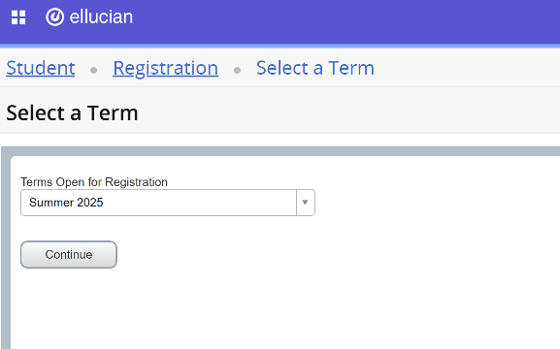

Select a term for registration using the drop down.

If you have any holds, this is where you will receive a notification that you cannot go further
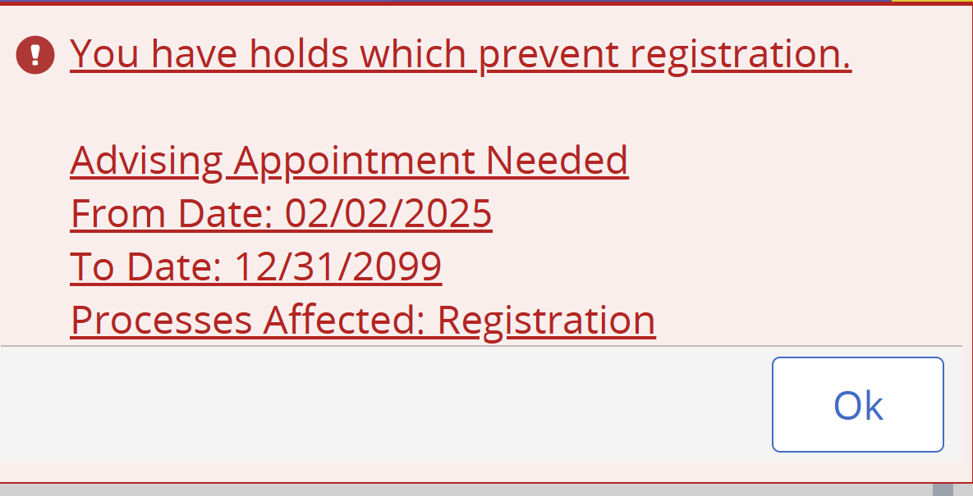

The Search Results page has three panels.
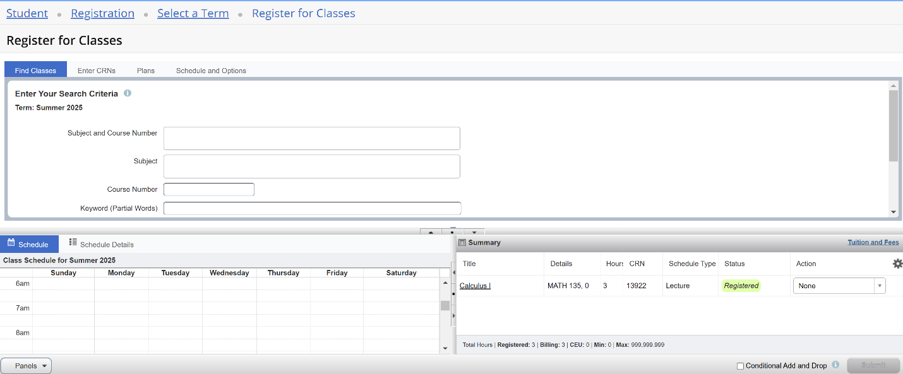

The panels can be minimized or maximized by selecting the toggle arrows or reset back to default by selecting the reset button.
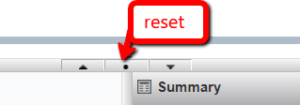
- Search Results: Allows you to search for classes for the selected term.
- Schedule: Provides a visual list of registered sections for the term. Sections will be identified by color, which will allow the student to view schedule conflicts.
- Summary: Lists selected sections. Students will then choose registration or remove.
To register for classes, you can select from three options – find classes, enter CRNs, and Plans.
Find classes - basic search.
Find classes - advanced search
Once you locate the course you can add it to your summary on the bottom right.
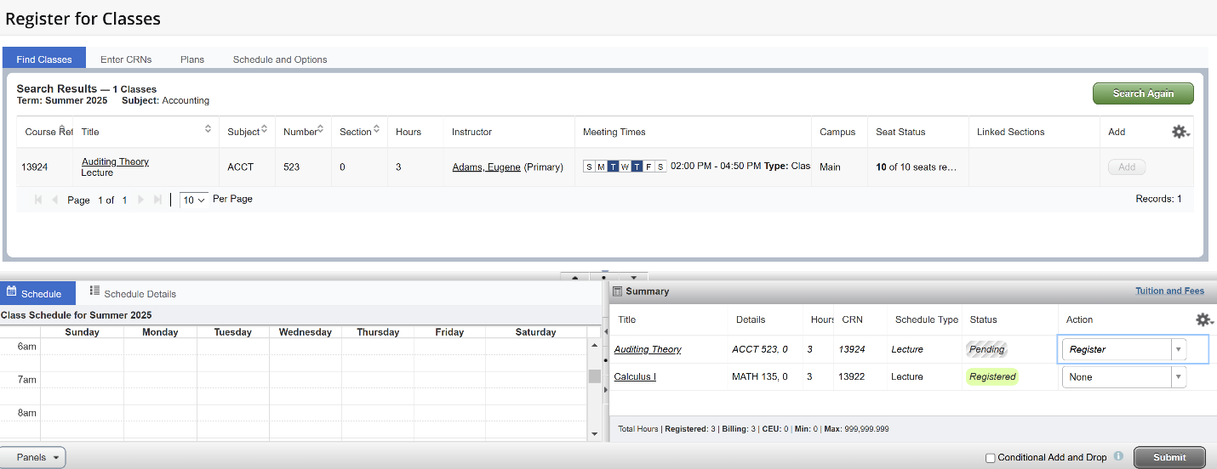

Enter CRNs
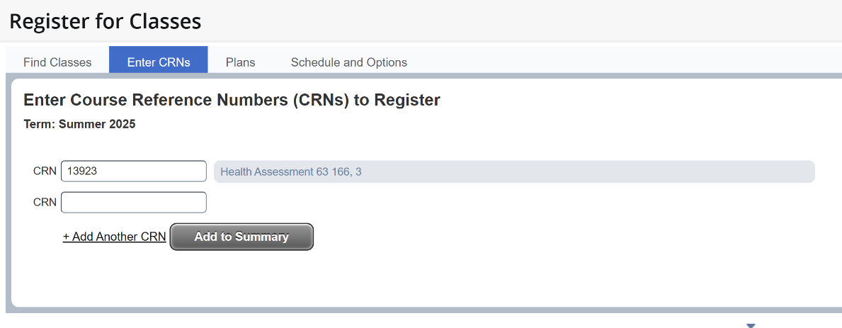
Plans
Once you have created a plan you can register for it on the Registration page. When you have located and added the courses to your summary you can chose an action – student registered or remove
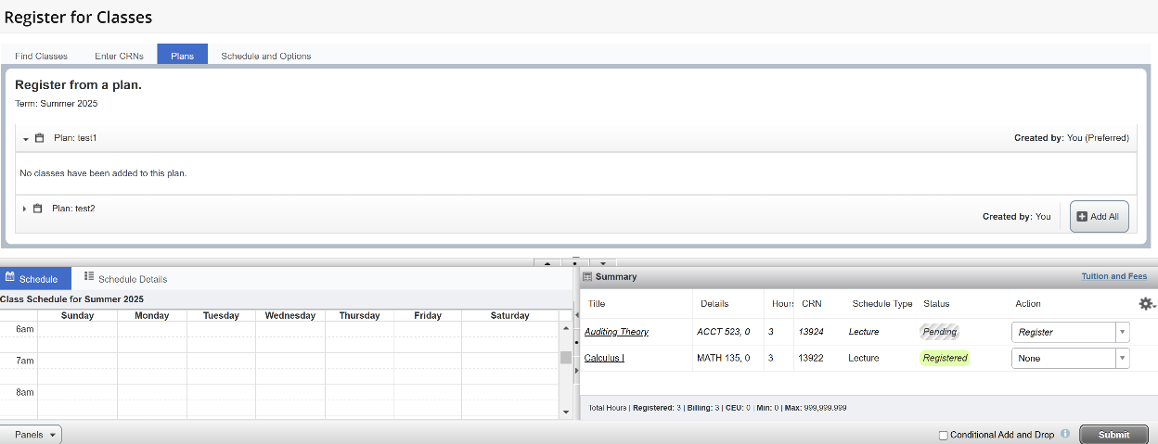
If there is a registration error, you will receive a notification and the action will change to remove.
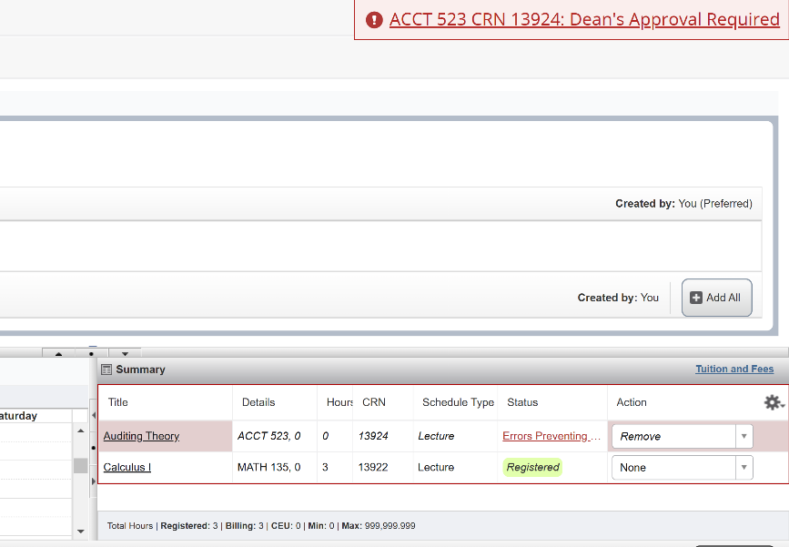
Once registered you can drop or withdraw from the course. Please refer to the Academic Calendar for important term dates.
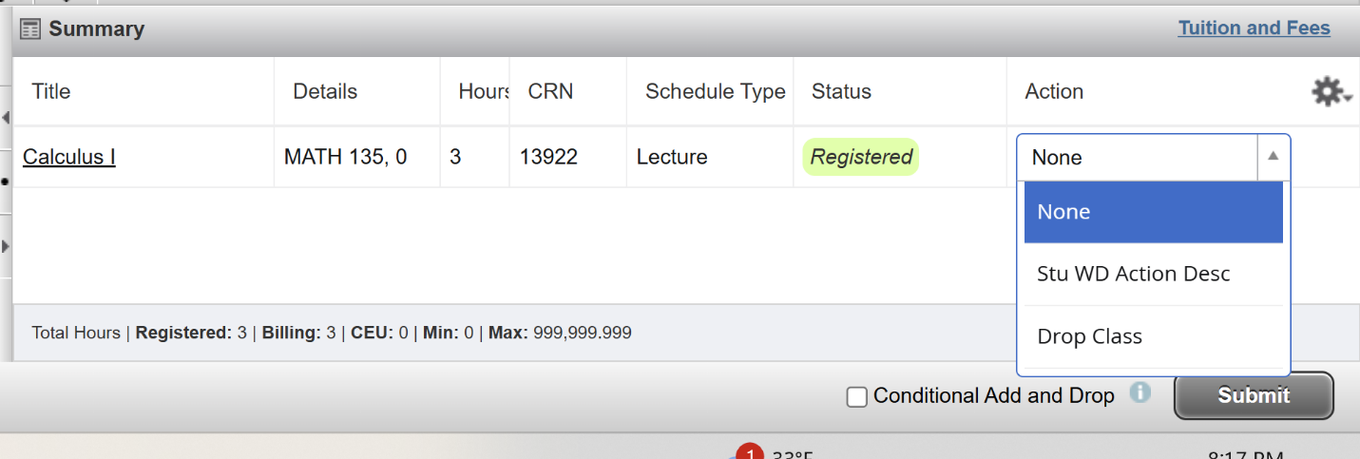
Now you can view your registration summary, weekly schedule, and schedule details.
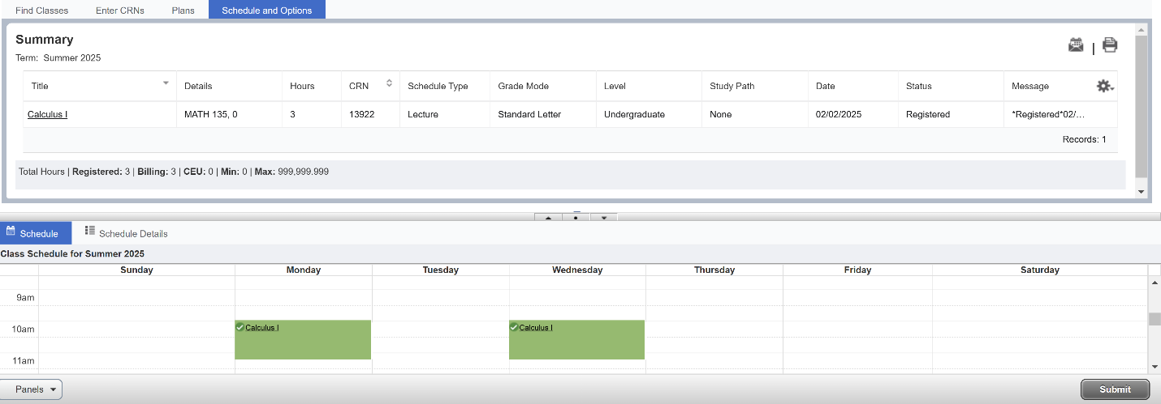

WAITLISTING

A waitlist is an electronic list of students who want to enroll in a course that has reached maximum capacity (closed).
Many regular registration rules apply to the waitlisting process. Inability to waitlist or move from a wait list into a course may be due to one or more of the following registration restrictions:
- Class level
- Account Holds
- Field of Study (Major/Minor/Concentration)
- Pre/Co-requisites
- Preapproval from the instructor/department
- Time conflicts
- Maximum credits exceeded
- Others (refer to the Registration Error Message section below)

How to waitlist an individual course
Identify whether the section is full and if there is a waitlist.
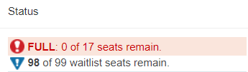
Select Add and the course will be entered into the summary section, with a waitlist option in the drop down.
How to waitlist a linked course
Linked courses have a waitlist on the section with the lower capacity. Add the course to the summary section and select waitlist.
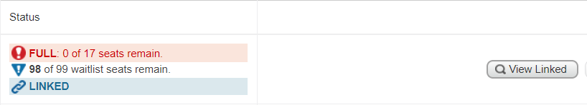
How to register after receiving a waitlist notification
After you have received the waitlist notification you will need to select the Student Registered option in the Action drop down.
If you are waitlisted for a linked course you must add the course to your summary and select the Student Registered option for both sections at the same time.

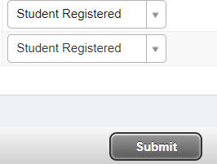
NOTE: A faculty member teaching a course may, at his or her discretion, provide another student with an override to allow that individual to register for a course, and that seat will become unavailable to the waitlisted student. If that occurs, the student will need to contact the faculty member (or academic department) for more information, but they should be aware that he or she is not required to add you to the course

Waitlist Information
A waitlist is an electronic list of students who want to enroll in a course that has closed.
Many regular registration rules apply to the waitlisting process. Inability to waitlist or move from a wait list into a course may be due to one or more of the following registration restrictions:
- Class level
- Account Holds
- Field of Study (Major/Minor/Concentration)
- Pre/Co-requisites
- Preapproval from the instructor/department
- Time conflicts
- Maximum credits exceeded
- Others (refer to the Registration Error Message section below)

Waitlisting Details and Procedures
- Closed - # Waitlisted:
  - Closed indicates no regular seats are available.
  - The number provided indicates the number of students currently on the wait list.
  - The student can only waitlist this course.

- Open – Reserved for Waitlist:
  - Open indicates regular seats available
  - Reserved for Waitlist indicates the available seats are reserved for a student or students on the waitlist for the course
  - The student can only waitlist this class since, currently, waitlisted students have preference.

If you can waitlist a class, select ‘Wait List’ from the ‘Action’ menu and click on the ‘Submit Changes’ button. Once a seat becomes available, you will be notified through your Marauder email account that you are able to register for the CRN number you selected to wait list.
YOU WILL NOT BE AUTOMATICALLY MOVED FROM THE WAIT LIST INTO A COURSE.
As a courtesy to your fellow students, please drop yourself from any courses you are waitlisted for that you don’t intend to take.
Note that during the window of time you are given in your notification to add the waitlisted section, you can add or drop the waitlisted class in the Add or Drop Classes screen in Banner. To add the class, enter the CRN in the ‘Add Classes Worksheet’ and click submit. This will register the student for the course, even if it was previously dropped.
NOTE: A faculty member teaching a course may, at his or her discretion, provide another student with an override to allow that individual to register for a course, and that seat will become unavailable to the waitlisted student. If that occurs, the student will need to contact the faculty member (or academic department) for more information, but they should be aware that he or she is not required to add you to the course.

Waitlisting FAQs for Students
How does waitlisting work?
Students who attempt to register for a class that is full may put themselves on a waiting list. When an open seat becomes available, an email will be sent to the Millersville email address of the student at the top of the waiting list. The student will have a certain amount of time (specified in their waitlist notification email) to go online and add the class.
The open seat will be reserved for that student and no other student may login and register for that seat during the amount of time allotted to the notified student.
If the student does not respond, the next student on the list will be notified and will be given an opportunity to respond.
As a common courtesy to other students, it is expected that you will drop yourself from any waiting lists (or classes) that you do not intend to take.
How do I receive waitlist notifications?

Waitlisting notifications will be sent to students’ Millersville student email accounts.
Can I waitlist for a course that requires a prerequisite or co requisite that I currently don’t have?
Students must meet all of the course prerequisites and requirements in order to sign up for its waitlist. Faculty and/or departmental overrides will allow students to waitlist for courses that would normally be restricted to them (See the Permission to Enroll in a Class form on pg 30)
How do I sign up for a waiting list?
All registration for waiting lists must be done online. Directions are available in this document under Waitlisting Details and Procedures (pg 25).
Is priority assigned to waitlists?
Seniors get priority on waitlists while all other classes are first-come-first-served.
Is there a way for me to see my position on a waitlist?
No – students cannot currently see their position on a waitlist.
What happens if I don’t register for a course within the allotted time period mentioned in my notification email?
If you do not register within the time period mentioned in your email (the clock begins ticking at the time the email is sent), you will automatically be dropped from the waiting list. The next student on the waiting list will move to the top of the list. For this reason, if you are waitlisted for a class it is HIGHLY recommended that you check your marauder email at least twice a day.
When can I begin adding myself to the waitlist for a course?
You can begin to add yourself to the waitlist for a course during the times you normally register for courses on MAX.
Are there times when wait listing will not be available or times when I won’t receive notifications of open seats?
When registration on MAX is closed off for you, you will not be able to waitlist for classes or register off a waitlist for a class. See Important Dates & Deadlines (pg 4) for these dates.
I received notification that I’m able to add a class off of the waitlist but when I try to, I’m getting a message that the class is closed and I cannot add it! Why is that?
A faculty member may, at his or her discretion, provide another student with an override to allow that individual to register for a course, and that seat will become unavailable to the waitlisted student. If that occurs, the waitlisted student will need to contact the faculty member (or academic department) for more information, but they should be aware that he or she is not required to add you to the course.
May I get on the waiting list for more than one section of the same course?
Yes. You may waitlist for more than one section of the same course. Also, if you are registered for a course, you may waitlist yourself for additional sections of the same course. If you are waitlisted for a course you have no intention of taking, please do your fellow students a favor and drop yourself from the waitlist and let someone else have the course.
May I get on the waiting list for a class that has a time conflict with another course?
Yes. Although you may not register for courses with time conflicts, you may add yourself to the waiting lists of courses that have time conflicts with courses for which you are registered or with other courses that you have waitlisted. If you are notified via email that a seat is now available for a waitlisted class, you must drop any course for which you are registered that has a time conflict before you may register for the waitlisted course (or, if the time conflict is less than 15 minutes in length, get permission to register via the Time Conflict permission form, pg 30).
How does waitlisting work with fee payment deadlines?
If you have an outstanding balance at any of the fee payment deadlines, you may be dropped from your classes. If you are dropped from your classes, you will also be dropped from any waiting lists. If you resolve your outstanding balance, it will be your responsibility to re-add yourself to any waiting lists from which you were dropped from; you will not retain your original position on those waiting lists.
At what point does waitlisting stop?
For Spring and Fall, wait lists will stop functioning 11:59 PM on the last day of Drop/Add. For Summer and Winter, waiting lists for a class will stop functioning 11:59 PM on the first working day following the first class meeting (Example: for class that begins on a Friday, the last day to Drop/Add would be the following Monday).
How can I get on a waiting list for a class that also has a lab and/or recitation component?
If you want to waitlist for a class that requires a lab and/or recitation:

- For classes that have a LAB component, you need to waitlist for the LAB.
- For classes that have a RECITATION component, you need to waitlist for the RECITATION.
- For classes that have a LAB & RECITATION component, you need to waitlist for the LAB.
If you receive a waitlist notification confirming that you can add the lab/recitation off the waitlist, you need to register for the lecture and the lab and/or recitation simultaneously by:
- Locating the lecture (and recitation for some PHYS courses) section attached to the lecture through the Web Schedule AND…
- Logging into MAX and go to Registration – Drop/Add Classes AND…
- Changing the Action button for the lab/recitation from Waitlisted to **Registered** AND…
- typing in the accompanying lecture (and recitation for some PHYS courses) CRNs in the Add Classes Worksheet near the bottom of the page AND…
- clicking on Submit Changes.

I’ve been given an override to add a course I’m waitlisted for but I’m getting a “Duplicate Course” error when I try to add the course! What’s wrong?
You must drop yourself from the waitlist of the course that you were given an override for before you attempt to add the course to your schedule.
I received a waitlist email, but when I tried to register I couldn’t because of a registration hold. What’s wrong?
All registration holds must be cleared prior to any registration activity (this includes waitlisted classes). You can review your holds on MAX.
I accidentally dropped the class I had been waitlisted for but had received notification that I was able to register for it. How do I get back in?
As long as you are still within the time period mentioned in your waitlist confirmation email, you can add the class by going to the Drop/Add Classes screen in MAX registration. You will need to type in the CRN in the Add Classes Worksheet and click submit changes. This will register you for the class and not put you back on the waiting list.

Registration Error Messages
The following is a list of the registration errors you might receive while registering online for classes (the error messages will come up under Status after attempting registration):
1. Permission of Instructor Req. To obtain written permission, please contact the department chairperson for an override and/or submit a Permission to Enroll in a Restricted class form (see pg 30) to the applicable department.
2. CRN does not exist. The CRN you entered is incorrect; please check the schedule booklet or web for the correct number. This usually occurs if you submitted the wrong term. Please be sure the term and the CRN match.
3. Level Restriction. Course is restricted to a different level than your course level (in this case graduate student). To obtain an override, you must submit a Permission for an Undergraduate Student to enroll in a Graduate Class form (see pg 30) to the applicable department. Once signed, this form is processed in the Registrar’s Office. Note: If you are an undergraduate seeking to take a graduate-level course for graduate level credit, use the Request for Undergraduates to Take a Millersville Graduate Level Course for Graduate Credit form, available on the Graduate Student Form center.
4. Section status prohibits registration. This course is currently not available; the course may be on hold, closed or cancelled.
5. Linked course required. If you get this message you need to register for the other course components, i.e., lecture, lab or recitation. Be sure to enter all CRNs which are required for the class. (Example: register for CHEM 111.00 lecture AND CHEM 111.0A lab)
6. Field of Study Restriction. Course is restricted to students with a particular major, minor or concentration. To obtain an override for this restriction, a Permission to Enroll in a Restricted class form (see pg 30) is required.
7. Prerequisite and Test Score error. This course has prerequisites or requires a placement test score that you have not obtained/completed. To obtain an override for this restriction, a Permission to Enroll in a Restricted class form (see pg 30) is required.
- Class restriction. Course is restricted to a class level determined by credits earned
(Senior (90+), Junior (60-89), Sophomore (30-59) or Freshmen (0-29)). To obtain an override for this restriction, a Permission to Enroll in a Restricted class form (see pg 30) is required.
- Degree Restriction. Course is restricted to a certain degree program (ex. BSE). To
obtain an override for this restriction, a Permission to Enroll in a Restricted class form (see pg 30) is required.
- Time conflict with CRN ####. Course conflicts with another class you are
registered for. To obtain an override for this restriction, a Permission to Enroll in a Class that has a Time Conflict form (see pg 30) is required. Once approved, this form is processed in the Registrar’s Office.

Permission to Enroll Forms

“Permission to Enroll” forms are available online on Millersville’s website in the Student Forms Center (http://www.millersville.edu/forms/):
Permission (Academic Department) to Enroll in a Restricted Class
Use this form to receive permission from the faculty to enroll in a course that has restrictions; such as permission required, prerequisites, limited to majors or class level (Jr., Sr., etc.). Note that any permission granted by this form also allows you to waitlist for a course otherwise unavailable to you. The completed form will be processed by the academic department, but you will still be responsible for registering for the course.
Permission for an Undergraduate Student to enroll in a Graduate Class for Undergraduate Credit
An undergraduate student who wishes to take a graduate 500-level course for undergraduate credit must have this form completed by the department offering the course. The completed form will be processed by the Registrar's Office.
Permission to Enroll in a Class that has a Time Conflict
If you have two courses that have a time conflict and one of the faculty is willing to work with you about missed time, please use this form. Register for the first course on MAX and bring this form to the Registrar's Office so you can be granted permission to register for the second course.
NOTE: The overlap in classes should not exceed 15 minutes.
Registration Notes for Education Majors

Clearances
Field experiences are required for many education major courses. To participate in a course with a field experience, a complete and valid Clearance packet is required to be on file with the Department of Field Services. In addition, some field experience assignments require additional documents, forms, and/or trainings. These will be requested on an ‘as needed’ basis.
Information regarding clearances, requirements, submission procedures and deadlines can be found on the Department of Field Services website: https://www.millersville.edu/fieldservices/clearances.php .
Courses/Blocks requiring a complete and valid clearance packet* (subject to change)
- ERCH 110/SPED 101
- Early Childhood Education/ Early Childhood and Special Education Foundation Blocks (EDFN 211, 241, ERCH 225, SPED 237)
- ERCH 496
- ERCH 421
- EDUC 424
- EDUC 580
- GFED 370
- SPED 101
- ERCH Professional Block II (ERCH 325, ERCH 422, ERCH 455, ERCH 465)
- SPED Professional Block II (SPED441, 442, 443, 444, 445)
- MDLV 486 (only offered fall w/MDLV 425)
- ERCH 316
- MDLV 425 (only offered spring w/ MDLV 486)
- MDLV Professional Block (MDLV 323, MDLV 445, MDLV 456, MDLV 466)
- SECED/MDLV Foundations Block (EDFN 211, 241)
- SECED Professional Block (AEST, ART, MATH, MUSIC)
- EDFN 590
- Student Teaching (undergraduate, post-bacc, and masters)
- Graduate Clinical Practicum
- RDED 624
- WELL 240
Early Childhood Education Foundation Block *
EDFN 211 - Foundations of Modern Education
EDFN 241 - Psychological Foundations of Teaching
ERCH 225 - Reading Foundations
Special Education Foundation Block *
EDFN 211 - Foundations of Modern Education
EDFN 241 - Psychological Foundations of Teaching
ERCH 225 - Reading Foundations
SPED 237 - Applied Foundations of Contemporary Special Education
Students should register for all classes in the same section in these blocks. Classes are held two days per week.
Important: Students should not schedule any other classes between 8:00 a.m. and 4:00 p.m. on the foundations block class days. During the field experience portion of the classes, students will meet in an urban school from 8:00 a.m. to 3:30 p.m. in place of these on-campus classes. Students are responsible for their own transportation to their field placement.
*Clearances: A complete and valid Clearance packet must be on file with the Department of Field Services to participate in courses with a field experience. Information regarding clearances, requirements, submission procedures and deadlines can be found on the Department of Field Services website: https://www.millersville.edu/fieldservices/clearances.php .
Secondary and Middle Level Foundation Block *
EDFN 211 - Foundations of Modern Education
EDFN 241 - Psychological Foundations of Teaching
Students must register for both classes in the same section in the foundations block. Classes are held two days per week during a 2½-hour block.
Important: Students in morning block classes should not schedule any other classes between 8:00 a.m. and 12:00 noon on the block class days. During the field experience portion of the classes, students will meet in an urban school from 8:00 a.m. to 12:00 noon in place of these on-campus classes. Students are responsible for their own transportation to their field placement.
*Clearances: A complete and valid Clearance packet must be on file with the Department of Field Services to participate in courses with a field experience. Information regarding clearances, requirements, submission procedures and deadlines can be found on the Department of Field Services website: https://www.millersville.edu/fieldservices/clearances.php .
Secondary Professional Block *
These courses must be taken together (all require APS placement):
English Majors: | ENGL 485 | Teaching of Secondary English
 | EDFN 330 | Instructional Tech, Design and Assessment
 | EDSE 321 | Issues in Teaching Secondary Education
 | EDSE 340 | Content Area Literacy for Diverse Classrooms
 | SPED 346 | Secondary Students with Disabilities in Inclusive Classrooms
Technology Education Majors: | EDTE 391 | Curr and Inst in Tech Ed
 | EDSE 340 | Content Area Literacy for Diverse Classrooms
 | SPED 346 | Secondary Students with Disabilities in Inclusive Classrooms
Foreign Language Majors: | FORL 480 | Teaching of Foreign Languages
 | EDFN 330 | Instructional Tech, Design and Assessment
 | EDSE 321 | Issues in Teaching Secondary Education
 | SPED 346 | Secondary Students with Disabilities in Inclusive Classrooms
Math Majors: | MATH 405 | Teaching of Mathematics
 | EDSE 321 | Issues in Teaching Secondary Education
 | EDSE 340 | Content Area Literacy for Diverse Classrooms
 | SPED 346 | Secondary Students with Disabilities in Inclusive Classrooms
Science Majors: | EDSE 435 | Teaching of Science
 | EDFN 330 | Instructional Tech, Design and Assessment
 | EDSE 321 | Issues in Teaching Secondary Education
 | EDSE 340 | Content Area Literacy for Diverse Classrooms
 | SPED 346 | Secondary Students with Disabilities in Inclusive Classrooms
Social Studies Majors: | EDSE 433 | Teaching of Social Studies
 | EDFN 330 | Instructional Tech, Design and Assessment
 | EDSE 321 | Issues in Teaching Secondary Education
 | EDSE 340 | Content Area Literacy for Diverse Classrooms
 | SPED 346 | Secondary Students with Disabilities in Inclusive Classrooms
Middle Level Field Experience Block II: | EDFN 320 | Instructional & Assistive Technology: Focus on Social Studies
 | EDUC 323 | Reading in the Content Areas
 | MDLV 486 | Teaching English Language Learners in Middle Level

Students should register for all classes in the same section in the professional block.
Important: Students will need to spend between 80-150 hours in a field placement (depending on major) and should arrange their schedule so that there is available time during the school day. Dr. Wright can address questions for secondary majors and Dr. Shettel can address questions for middle level majors.
*Clearances: A complete and valid Clearance packet must be on file with the Department of Field Services to participate in courses with a field experience. Information regarding clearances, requirements, submission procedures and deadlines can be found on the Department of Field Services website: https://www.millersville.edu/fieldservices/clearances.php .
Formal Entry Status (formerly APS)
The Pennsylvania Department of Education (PDE) has established requirements for certification to teach in Pennsylvania. To prepare students to meet these requirements, Millersville University has developed criteria for admission to, and retention in, Formal Entry courses. Formal Entry standing is conditional upon meeting and maintaining requirements throughout the degree program. Formal Entry status is not permanent and can be revoked.
Please visit the following link for information regarding Formal Entry at Millersville.
Formal Entry site: http://www.millersville.edu/cert/aps.php
Student Teaching *
The criteria for Admission to Student Teaching are:
- Grade point average of 3.0 at the time of student teaching. Effective Spring 2010, a GPA below 3.0 and above 2.8 will be accepted; however, teaching candidates with a GPA of 2.8-2.99 must take and pass a Pre-Service testing option as per PDE regulations AND higher scores on the content area certification examination(s) will be required in order to meet final Certification requirements in PA. Please see the Certification Office for a list of Certification testing scores with the GPA deviation.
- Must have full APS status.
- Satisfactory professional behaviors record.
- A complete and valid clearance packet on file with the Department of Field Services. (by the student teaching clearance deadline date).
- Evidence of having current liability insurance.

Students are assigned to full-time cooperating teachers and to University supervisors in area school districts for a full semester of student teaching provided the following has been completed:
- The above listed 1-5 criteria for Admission to Student Teaching have been met;
- A Student Teaching Application has been submitted to Field Services one year prior to the student teaching semester;
- Additional requirements, as noted on the Student Teaching website (link below), have been completed.
Additional information is available from the Department of Field Services on the website: Student Teaching | Millersville University

Special Registration Procedures

Auditing a Course

An individual who is not concerned with earning credit may audit a course upon approval of the course’s instructor. An auditing student attends classes and participates in class discussions but does not take examinations, write papers or fulfill other requirements. The student’s transcript does not record a grade but notes that the course was audited. Standard tuition and fees are charged. The option to take a course on the pass/fail basis may be exercised until the end of the add period for a class.
The form used to request to take a course via audit can be obtained from the Registrar’s Office.

Franklin & Marshall Exchange

Millersville University has an agreement with Franklin & Marshall College whereby Millersville University students may take courses not offered at Millersville at Franklin & Marshall without a tuition charge from F&M. Students seeking to take advantage of this program must meet the following requirements:
- Good academic standing (QPA 2.0 or better at time or registration).
- Full-time student (the F&M course may be part of your full-time load).
- Participating in a degree program.
- Undergraduates only.
- Limited to Fall and Spring semesters only.

Only courses not offered at Millersville University may be taken at F&M College through the Exchange Agreement. Students are permitted only one F&M course per semester.

The F&M Exchange Registration form is obtained through the Registrar’s Office.

Taking a Course Pass/Fail

To stimulate and/or satisfy intellectual curiosity, students are encouraged to engage in challenging study on an elective basis. The pass-or-fail option provides the opportunity for a student to enter a course that (s)he might ordinarily avoid.
Accordingly:
- A student may enroll in no more than a total of two courses pass/fail.
- The student must pass 60 or more credits before electing a course pass/fail.
- The student must have a minimum cumulative GPA of 2.80 or obtain permission of the instructor.
- The pass/fail option is restricted to courses numbered 300 or above. However, a 200-level course may be taken pass/fail with the prior approval of the instructor. 100-level courses may not be taken pass/fail.
- Courses which may not be taken on a pass/fail basis are the following:
  - Courses taken to satisfy requirements in the major.
  - Courses taken to satisfy required-related areas in the major.
  - Professional Education requirements.
  - Courses used to satisfy General Education requirements.
  - Courses taken in the minor.
- Courses taken on a pass/fail basis will be counted toward the total hour requirement for graduation, but those courses which are passed will not be included in the GPA computation on which academic honors and academic standing are based. Courses failed under the pass/fail option will be included when computing the GPA.
- The minimum grade a student must earn in order to be awarded a “pass” grade is “D-.“
- The option to take a course on the pass/fail basis may be exercised until the end of the add period. Having properly registered for a course on a pass/fail basis, a student still has the option to take a letter grade instead of a pass/fail grade provided that the decision to change is filed with the Registrar the week prior to final exams.
- The pass/fail option is limited to students not on probation at the time of registration.

The Pass/Fail form is online.

Course by Examination

Students who feel they have already mastered the material in a Millersville course may “challenge the course by examination,” taking a test of the course content instead of enrolling for the course itself. Students may challenge most courses in which they have not received a grade, and which has not been waived because of demonstrated competency or advanced placement. Because of content and structure, some courses may not be challenged by examination.
The examination is given at the convenience of the instructor. The grade earned is entered on the student’s record and calculated into the GPA whether a passing grade is earned.

The Course by Examination form is available from the Registrar’s Office. Contact the Office of Student Accounts (717-871-5101) regarding the fees involved.

PASSHE Visiting Student
Intended for undergraduate students who wish to enroll in a course at another PASSHE school and have the course come back to Millersville as if it was a Millersville course.This is for courses NOT appearing on the course share website. Registration and payment will be made to the PASSHE school offering the course, and it will transfer to Millersville (as resident credit) upon completion of the course. Please note that any coursework taken through this program will come in as a Millersville course and will affect your GPA nor can it be used to repeat a course already taken at Millersville. Please read the attached policy for further restrictions on use. The form is available online
PASSHE Course Share
For courses appearing on the approved list for PASSHE course sharing. Courses registered via course share will show up on a student's Millersville schedule and the student will pay Millersville directly for the credits. Please note that any coursework taken through this program will come in as a Millersville course. The form is available online

Independent Study

Independent study allows students to pursue, with faculty supervision and guidance, an academic area of interest not available through an established course. To apply, complete a special studies assignment form, available in online, and obtain approval for the proposed topic and faculty supervisor from the department chairperson and school dean before the start of the term.

Individualized Instruction
Individualized instruction allows students to complete an established course during a semester in which it is not offered. Approval to pursue a course through individualized instruction is granted only under special circumstances. To apply, complete a special studies assignment form, available online, and obtain approval for the proposed topic and faculty supervisor from the department chair person and school dean before the start of the term.

Cooperative Education/Internships
Cooperative Education (Co-op) and internships are optional learning experiences that take place in a work setting rather than in a classroom. Co-ops and internships are the result of partnerships between the University and employers in business, industry, government and human services.
For more information, contact the Career Center at 717-871-7655.

Registration Tips
- Before you register, meet with your academic adviser to discuss appropriate classes and to also have your advisement hold removed, if applicable (see page 7). Make a list of the courses and CRNs you plan to take. Have several alternative courses ready in case your first choices are not available.

- Make use of the Registration Preparation Checklist and Schedule Planning Grid at the end of this guide to make sure you’re prepared for registration and that the courses you’re planning on taking fit your schedule!

- New Transfer Students if you are attempting to register for a course with a prerequisite that is not yet transferred to your MU record, contact the Registrar’s Office (717-871-5005) for assistance in completing the registration for this course.

- If a course is closed, place your name on the waitlist. See page 25 of this booklet for more details. You may also contact the department chairperson for permission to enroll in a closed course (in doing so, you will need to fill out the “Permission to Enroll in a Class” form – see page 30)

- Don’t panic! There are many sources of assistance, including your major department chairperson, assigned academic adviser (see degree audit printout), and the Office of Academic Advisement.

- Remember to click on the “Submit Changes” button before exiting the registration form.

- If a course is closed to you because of a major restriction, contact the department offering the class for permission overrides. If the department processes an override for you to get in a course, you will need to add it on MAX. See page 30 for the required forms.

- Don’t worry if you cannot get all of the classes you need (or want) right away – you can add and drop Spring and Fall courses via MAX through the first week of classes (check the Registrar’s Office Website for possible deadline changes) and seats may open up for you! You should check the web schedule frequently for course availability and remember to utilize the waitlist!

- Consider taking Winter and/or Summer session courses at Millersville. They’re a great way to supplement your coursework and fulfill prerequisites that you need in order to register for future courses!

Drop/Add & Withdrawal Procedures at MU
The Drop/Add period begins with the start of the semester and is not dissimilar to early registration in that it takes place online through MAX and is processed through the same means as early registration
Students who register for classes at MU are responsible for the accuracy of their class schedules. Drop/add is the tool by which students can modify their schedules to this end, and it can be done conveniently online through MAX. When done by the published deadlines, online drop/add can help students avoid the problems of additional charges/fees and/or grades on their records. Continue reading for important information regarding drop/add for upcoming terms!

Information for Summer
Summer & Fall drop/add differ somewhat from one another. Primarily due to the variety of start dates for classes, Summer drop/add is structured to accommodate each section. For this reason, please read the following general instructions & review the details concerning deadlines to drop, add & withdraw from Summer classes. (Contact the Registrar's Office at 717-871-5005 for deadlines on course meeting dates not listed.)
How does drop/add work for Summerr?
- Non-payment & non-attendance are not substitutes for drop/add. There is no automatic drop for unpaid or unattended classes!
- See the Drop/Add Withdrawal web page for deadlines to drop/add/withdraw from classes
- The online registration system will be available through the end of drop/add for each Winter class.
- Students will log in to MAX & choose the "Add/drop courses" option on the Registration menu. See here for more details and instructions.
- Classes may be added only if seats are available & the student meets course prerequisites or other restrictions (such as test scores or major.)
- Faculty signatures are not required to add or drop courses.
- Students who add after a course begins must contact the instructor for any missed materials or information, including Desire2Learn (D2L) access.
- The official drop date is the date a winter session course is dropped online. Remember, there is no automatic drop for non-payment or non-attendance!
- Faculty can give overrides to students to permit registration into an otherwise unavailable class. You still need to register on MAX after you are given an override!
What is the procedure to withdraw from a Summer course?
After the drop/add period ends, students still have the option to withdraw from a class by the published deadline. To withdraw, students must either:
- Complete an online Course Withdrawal form;
OR
- email the faculty member & copy the registrar@millersville.edu &
- ask him/her to forward the email with the approved withdrawal to the Registrar's Office.
- The effective date of course withdrawal will be the date the student initiated the request (provided the date falls within the withdrawal period for the class.)
If you have questions concerning refunds for Winter classes, please review the Winter Refund Policy on the Student Accounts website.

Information for Fall 2026
Students can drop & add Fall classes using MAX through August 31st. Because most classes begin on August 24th, the drop/add process is simple -- students can drop & add online until the published deadlines. See Important Dates & Deadlines (pg 4) for more details.
How does drop/add work for Spring 2026?

- Non-payment & non-attendance are not substitutes for drop/add. There is no automatic drop for unpaid or unattended classes!
- The online registration system will be available through the end of drop/add.
- Students will log in to MAX & choose the "Add/drop courses" option on the Registration menu.
- Classes may be added only if seats are available & the student meets course prerequisites or other restrictions (such as test scores or major.)
- Faculty signatures are not required to add or drop courses.
- Students who add after a course begins must contact the instructor for any missed materials or information, including Desire2Learn (D2L) access.
- The official drop date is the date a class is dropped online. Remember, there is no automatic drop for non-payment or non-attendance!
- Waitlisting will still be in effect during Drop/Add.
- Faculty can give overrides to students to permit registration into an otherwise unavailable class. You still need to register on MAX after you are given an override!

What is the procedure to withdraw from a Fall course?
After the drop/add period ends, students still have the option to withdraw from a class by the published deadline. However, students cannot use MAX to withdraw from a course. To withdraw, students must:
- Complete an online Course Withdrawal form
- submit the form by the withdraw deadline.
To withdraw from online or blended classes, students should review Registration Notes for Online or Blended Courses.
If you have questions concerning refunds for Spring classes, please review Millersville's Refund Policy on the Student Accounts website.

Registration Preparation Checklist
Use this checklist each semester to make certain that you are prepared for registration!
- Find your time to register on the Registration Appointment Schedule (located on the Registrar’s Website)
- Run your degree audit on MAX and print a copy to help you with schedule planning.
- Use MAX to search for classes. Find courses for your major or minor using the Subject search or try searching by other selection criteria, such as General Education courses. Check the course notes to make sure you meet prerequisites or other restrictions.
  - Course prerequisites and restrictions are enforced during registration all terms. You need to contact the course instructor ahead of time to request approval in courses requiring written permission or for waivers of prerequisites and other restrictions. If approved, the department will enter an override so that you can register for the course online.
- Review the academic calendar for important dates and deadlines that occur before and during the academic term.
- Contact your advisor or major department chair for advisement. If you are a graduate student, you should schedule an appointment with your program coordinator for advisement.
- Check your registration status on MAX before you register. If you have any registration holds, you must clear them to register – on the MAX “Registration” menu, click “Check Your Registration Status.”
- Register on MAX!

Major Department and Program Contacts
For the most up-to-date list of academic department and minor program contacts, please refer to:
https://www.millersville.edu/explore/contacts.php

